# Introduction

# Model Available

# Model Unknown

# Multi-Armed Bandit

For this portion of the project, the base domain was to evaluate the epsilon-greedy algorithm and a UCB algorithm in terms of regret. Due to the larger group size, our additional domain included altering the standard deviation, and providing brief analysis on convergence. Due to the vast amount of figures, they have been stored in the Appendix in collapsible headings, so that they can be minimized and selected parameters can be easily accessed.

The implementation of the UCB algorithm was quite simple, which was expected per the lecture discussion. This was especially true when coupled with the provided Bandit Simulator from Robert Geraghty, where the arm of the bandit could be pulled with only a few lines of code. As a result of the simple implementation, extra work was performed in terms of data collection to provide better analysis.

For collecting data, a few parameters were altered. The number of samples, the number of arms, and epsilon were all varied for the base domain. For each parameter instance, the UCB and epsilon-greedy algorithms were ran 100 times, and results were averaged. As a result, especially when viewing data on the epsilon-greedy algorithm, there will not be many large spikes as you might expect with an algorithm running fairly randomly. Regardless of not seeing the large spikes, the randomness still pushes the data trend downwards during the averaging process, and it is verified that the worst arms are still pulled when viewing the figures displaying the number of pulls on each arm.

In terms of analysis, the UCB algorithm outperforms the epsilon-greedy algorithm in most cases, though there are a few conditions to this statement. Primarily, the multiple (m) of samples and actions must be large enough. Since the UCB algorithm attempts to balance exploration and exploitation with enough exploration early on, if the algorithm pulls most of the arms early and has little samples left to exploit the better arms, it cannot adequately converge. This is seen in the figures where there are 99 arms on the bandit, and in cases where there are only 100 samples taken. Since all the arms are pulled, the UCB algorithm does not have enough time to converge. Even in the case with 1000 samples and 99 arms, the multiple is not enough for convergence. The convergence line does drift upward over time, however there are simply not enough samples to overcome the excessive exploration that is done. This is seen through the figures displaying the number of arms pulled for the UCB algorithm.

In this specific implementation, there are a bit of biases that aid the case of epsilon-greedy as well. When there is a tie in the payout average, the epsilon-greedy algorithm just chooses the last arm to pull. In this case, the last arm is the one with the best payoff. This results in the epsilon-greedy algorithm deciding early on that the last arms are the best to pull, and can converge very rapidly, whereas the UCB algorithm must explore more. If arm payouts were randomized, the differences in UCB and epsilon-greedy would be much more apparent. This can be noticed when epsilon is equal to 0.3. Since there is now a 30% chance that a random arm will be pulled, the epsilon-greedy algorithm is not able to exploit on its early convergence, pushing the overall payout downward. Once the UCB algorithm converges, the 30% randomness from the epsilon-greedy algorithm cannot compete in terms of regret. When looking especially at the 1000 sample cases when arms are less than 50, the UCB algorithm performs substantially better since the payouts are much more reliable.

When altering the standard deviation, there are some interesting results. The minimum reward is bounded as follows:

$$μ-σ\sqrt{h-1} ≤minimum payout ≤ μ-\frac{σ}{\sqrt{h-1}}$$

Where µ is the mean, $σ$ is the standard deviation, and h is the number of samples.

The maximum value is bounded on its maximum as follows:

$$maximum payout ≤ µ+ σ\sqrt{h-1}$$

When decreasing the standard deviation, the payouts trend closer towards their means. Likewise, when increasing the standard deviation, the payouts drift farther from their means. In the Bandit Simulation provided, the arm payouts are determined based on the number of arms that exist. Theoretically, for systems with fewer arms, there is not a substantial difference other than that convergence trends closer towards the actual reward means when the standard deviation is lessened. From the data collected, it is seen that this is true for both epsilon-greedy and for the UCB algorithm.

When increasing the standard deviation however, the epsilon-greedy algorithm begins to suffer. The UCB algorithm, once converged, starts to get much greater payout. Since the algorithm has converged, there is excess capitalization since pulling the best arm repeatedly yields results where the maximum payout can receive much higher rewards than the mean suggests. However with the epsilon-greedy algorithm, it cannot determine the best arm to pull. This becomes increasingly true when the number of arms increase. Since there is now overlap in possible reward (since the arm means + standard deviation can now cross territories with other arm means), the epsilon-greedy algorithm’s greedy approach starts to falter. For instance, take a parameter set of standard deviation = 0.2, samples = 100. Let’s compare two arms, one with mean of 0.5, and one with mean 0.6. At its extremes, the arm with means 0.5 can yield a reward of 2.49, and the arm with means 0.6 can receive a reward of -1.99. While these values are the extremes, it shows that the epsilon-greedy algorithm now will believe that the arm with lower means is the better option, and can get stuck pulling on that arm instead of trying to pull the arm with a higher means.

Issues with some of the data collection:

For the purpose of the report, we do have a very large number of figures. To try and show vastly different number of results, we limited ourselves to fewer parameters, such as 3, 5, 10, 50, and 99 arms, and 100 and 1000 samples. When looking at our figures, it does appear that our UCB algorithm can perform quite poorly. This is largely due to our poor selection in parameters. 99 arms and both 100 and 1000 samples is simply a losing scenario for the UCB algorithm. With the large number of arms and not enough samples, the epsilon-greedy algorithm will of course outperform it in almost every case.

While this specific data is helpful to demonstrate the importance of the number of samples vs the number of actions, if we were to repeat this project, we would likely have more “winning” cases for the UCB by ensuring that it had enough time to show convergence and its results from said convergence.

# Conclusions

# Appendix

## Base Domain: Standard Deviation = 0.1

### 100 Samples, 100 Trials, 3 Arms, Std Dev=0.1

#### 100 Samples, 100 Trials, 3 Arms, Epsilon=0.1 Std Dev=0.1

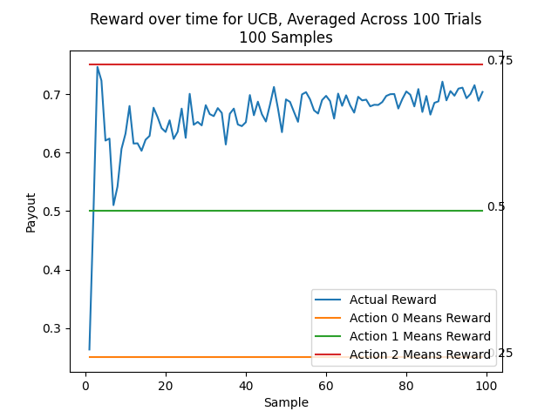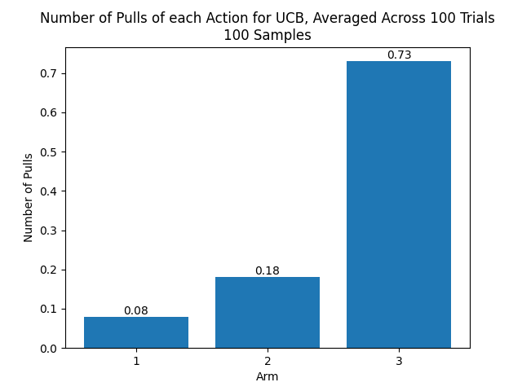

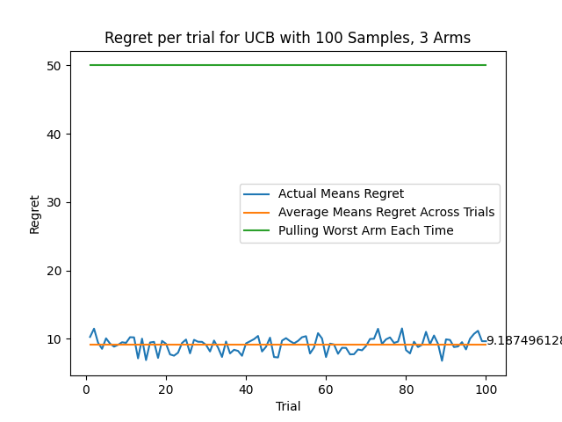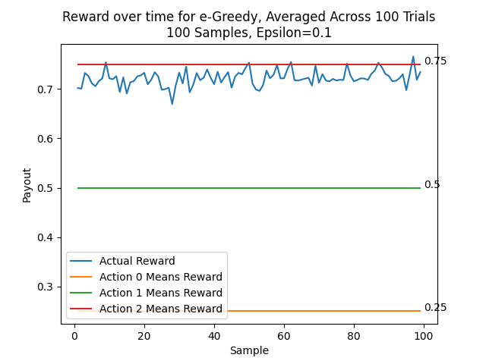

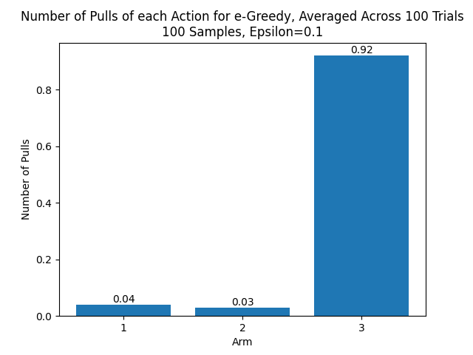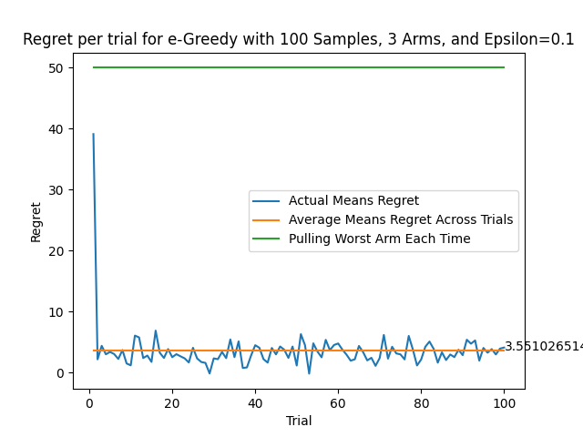

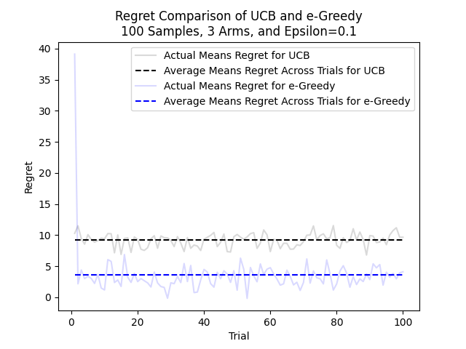

#### 100 Samples, 100 Trials, 3 Arms, Epsilon=0.2 Std Dev=0.1

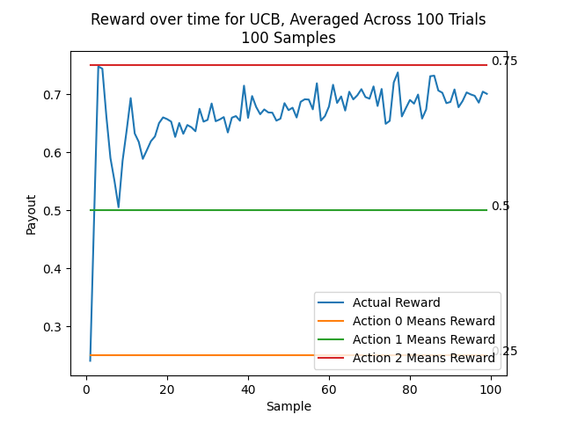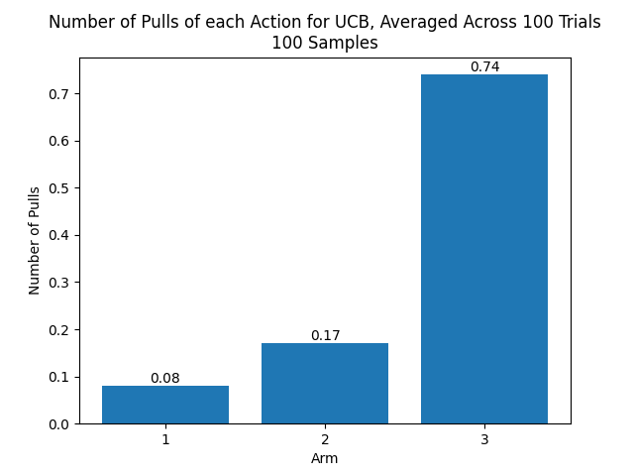

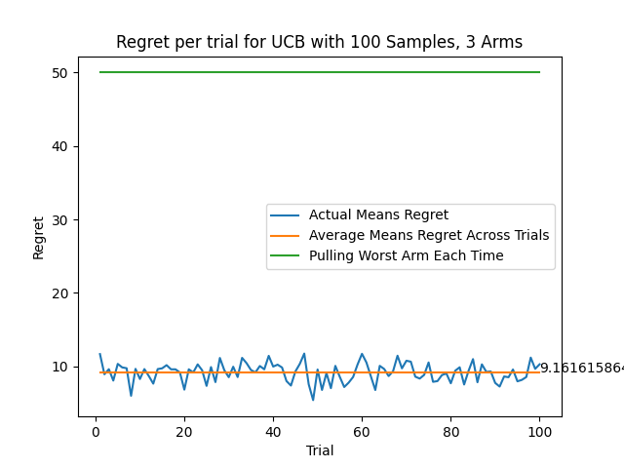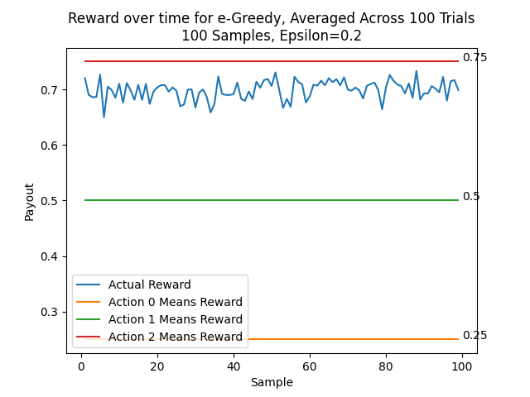

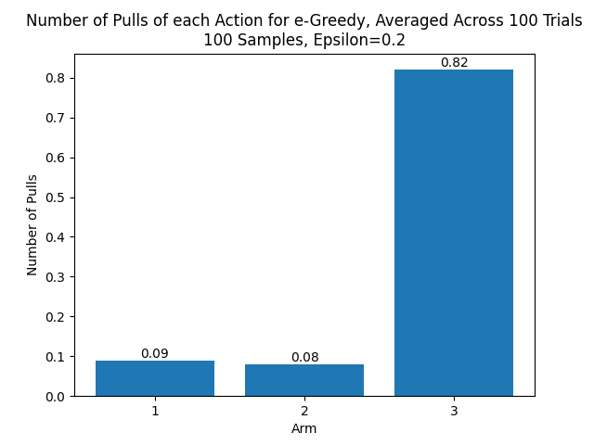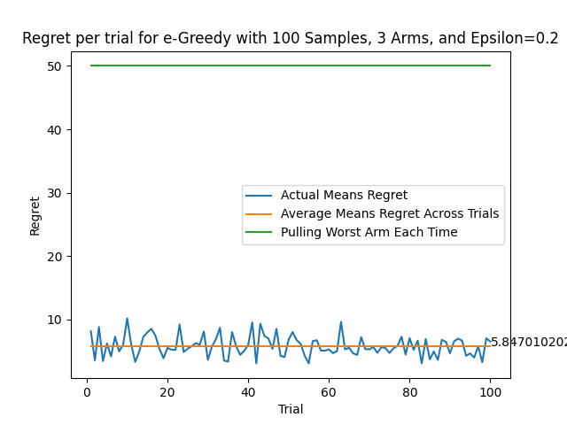

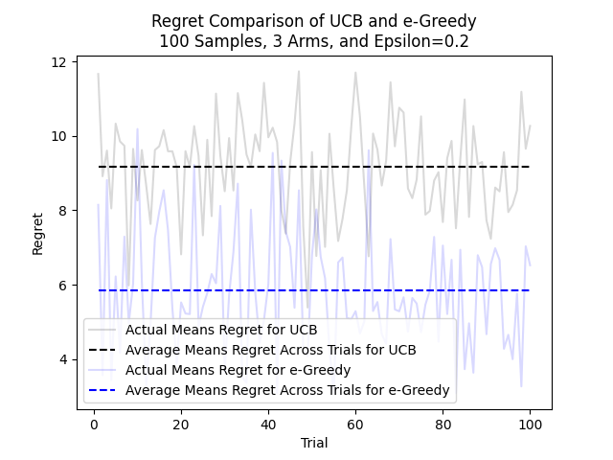

#### 100 Samples, 100 Trials, 3 Arms, Epsilon=0.3 Std Dev=0.1

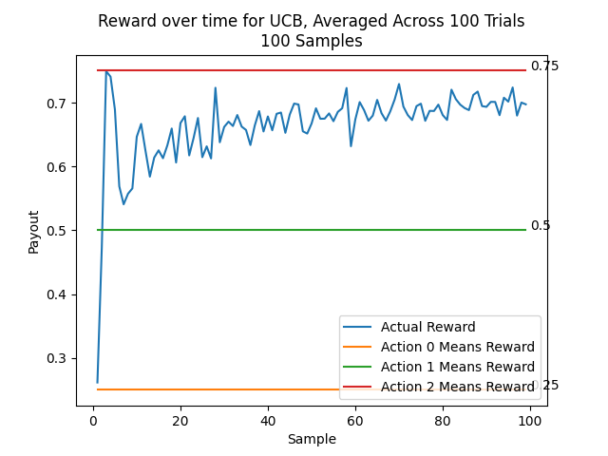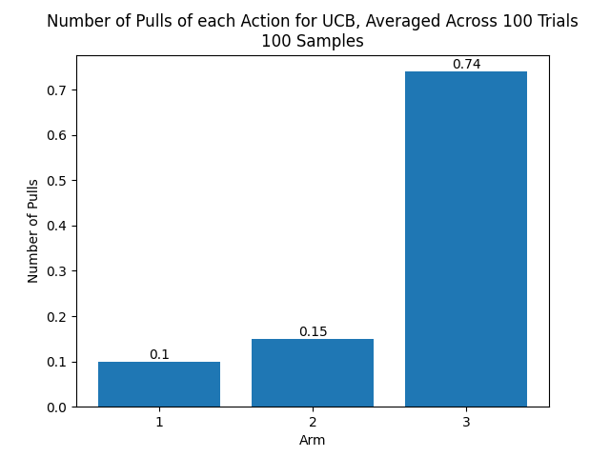

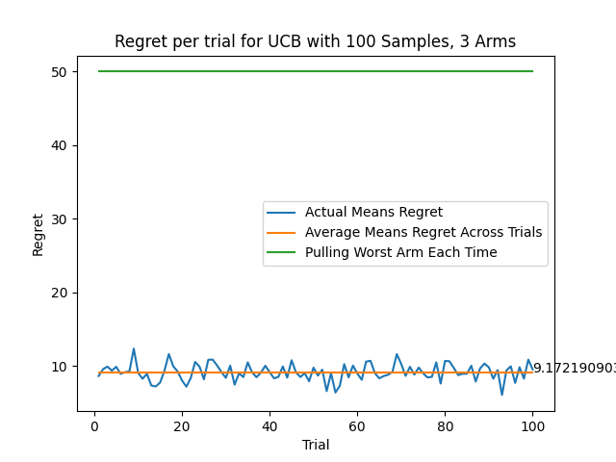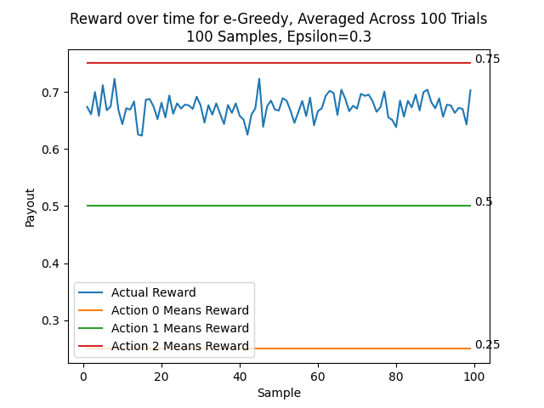

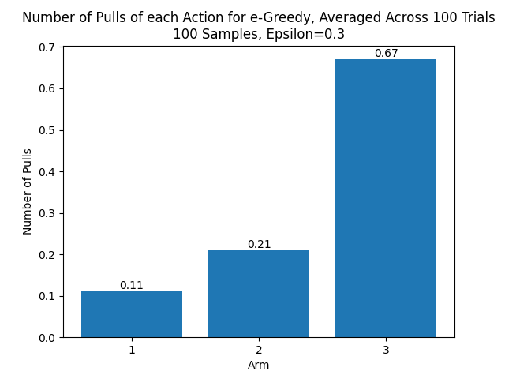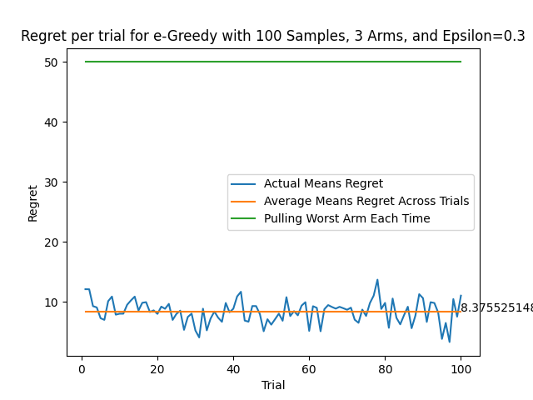

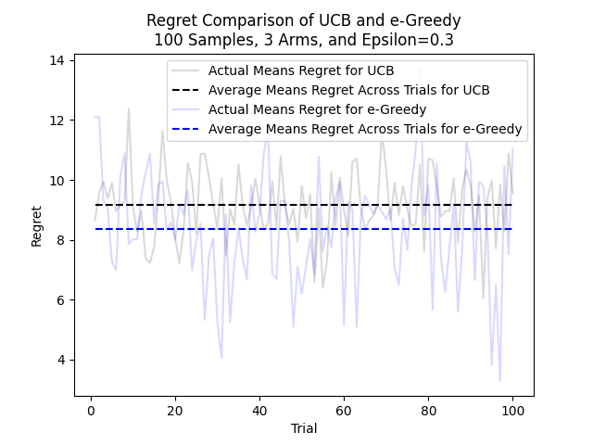

### 100 Samples, 100 Trials, 10 Arms, Std Dev=0.1

#### 100 Samples, 100 Trials, 10 Arms, Epsilon=0.1 Std Dev=0.1

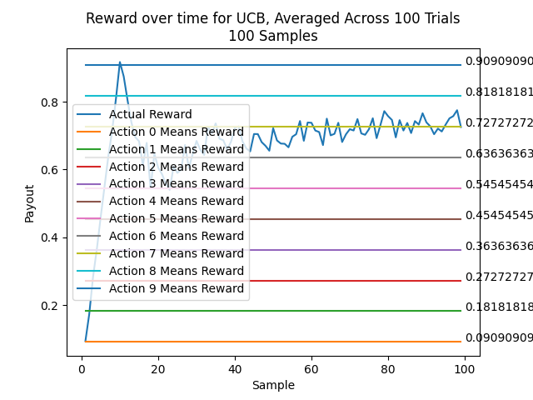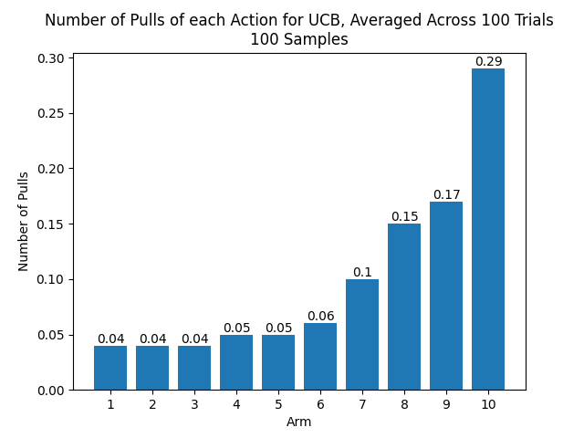

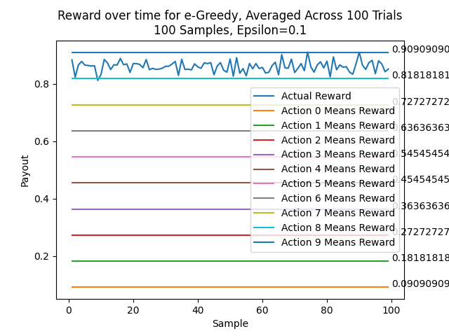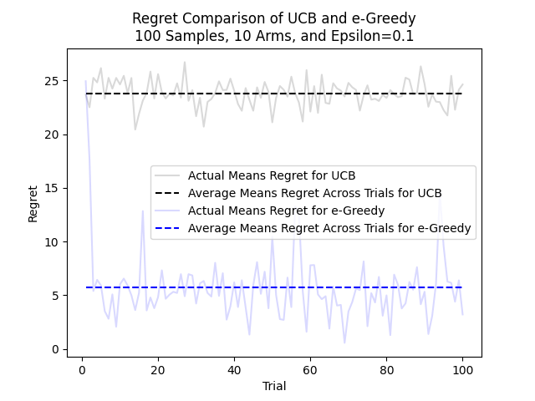

#### 100 Samples, 100 Trials, 10 Arms, Epsilon=0.2 Std Dev=0.1

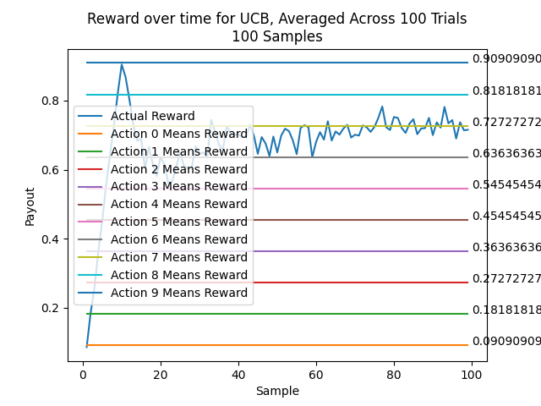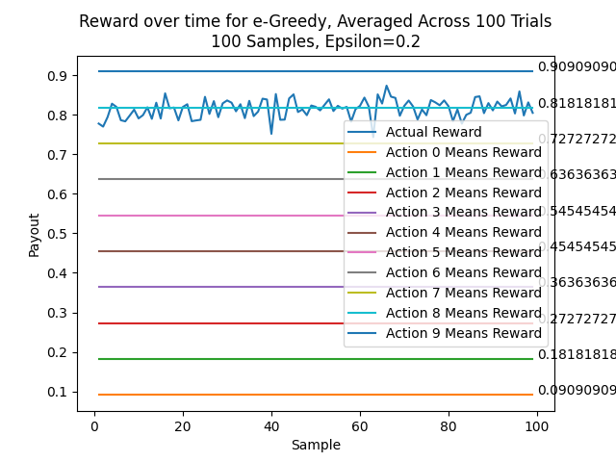

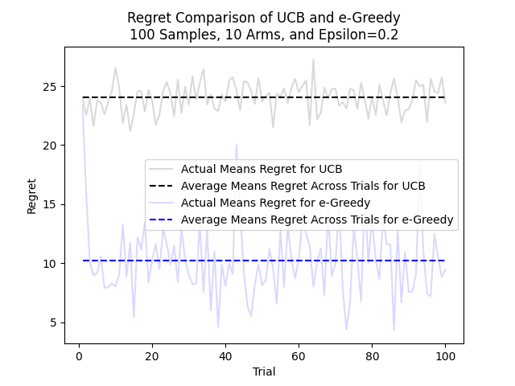

#### 100 Samples, 100 Trials, 10 Arms, Epsilon=0.3 Std Dev=0.1

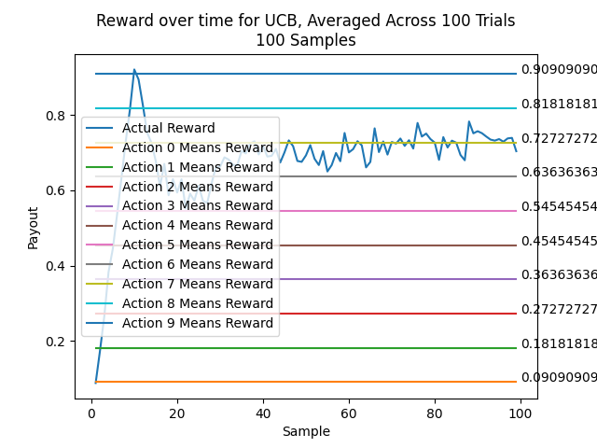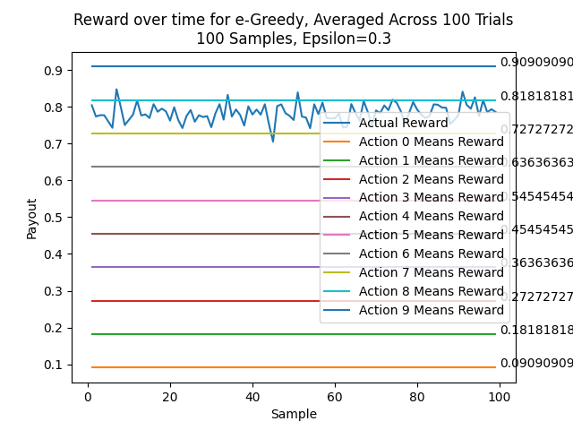

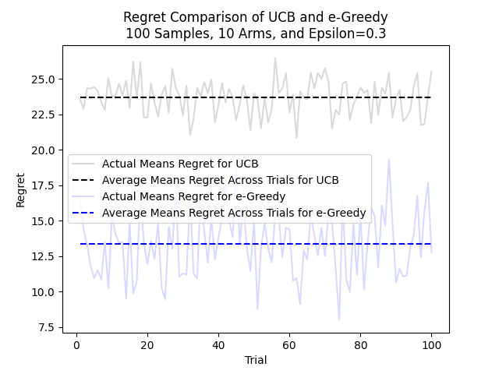

### 100 Samples, 100 Trials, 50 Arms, Std Dev=0.1

#### 100 Samples, 100 Trials, 50 Arms, Epsilon=0.1 Std Dev=0.1

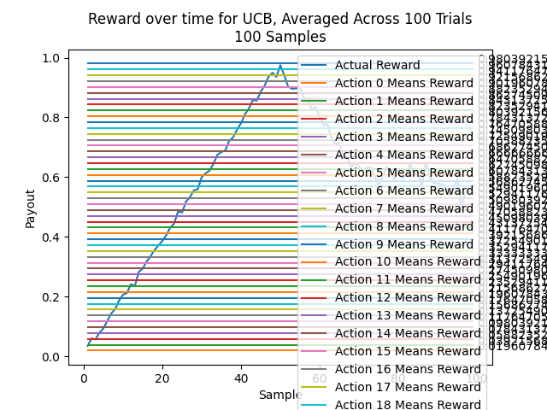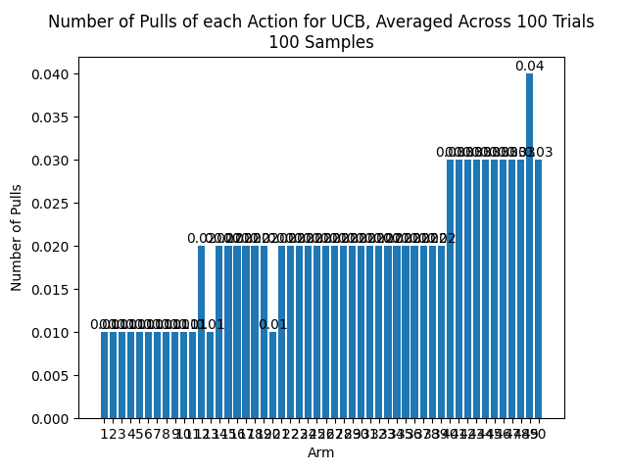

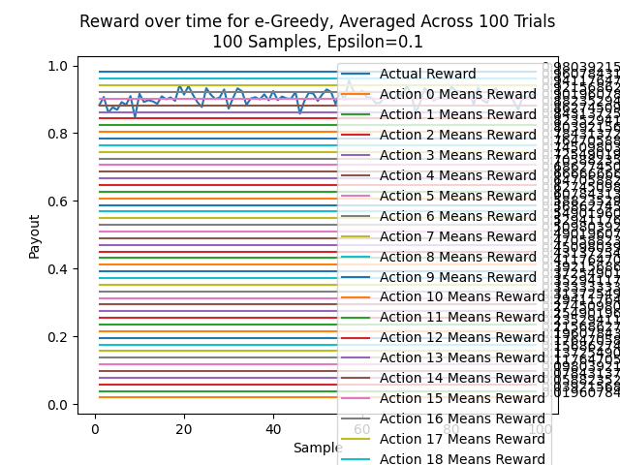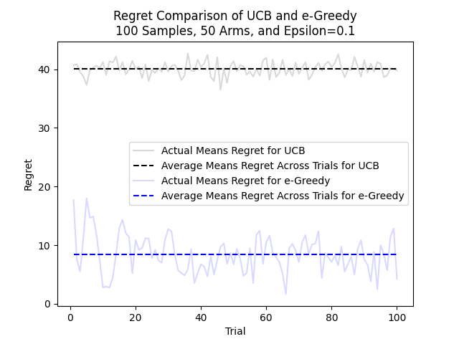

#### 100 Samples, 100 Trials, 50 Arms, Epsilon=0.2 Std Dev=0.1

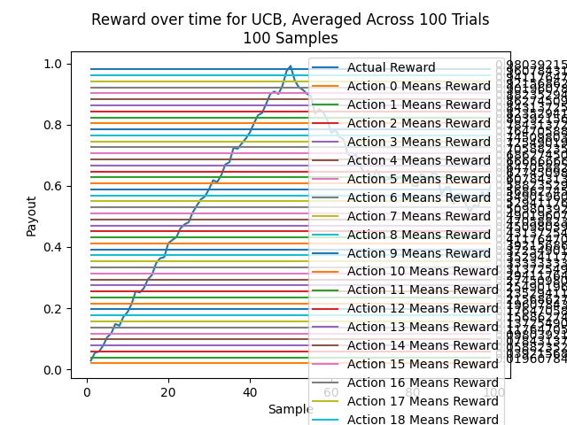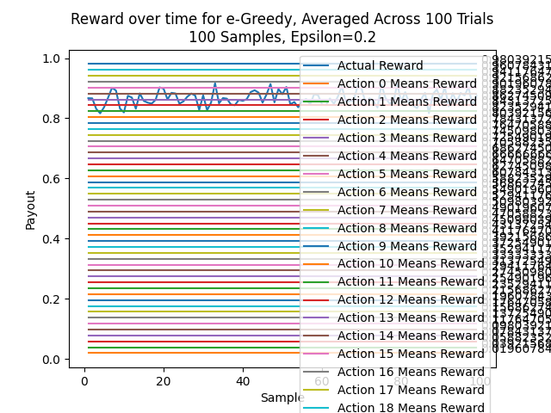

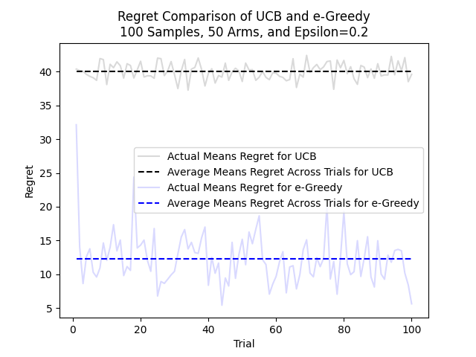

#### 100 Samples, 100 Trials, 50 Arms, Epsilon=0.3 Std Dev=0.1

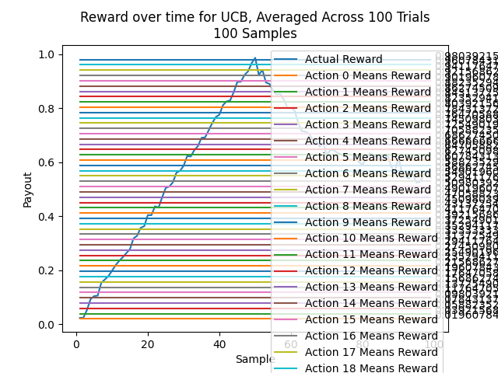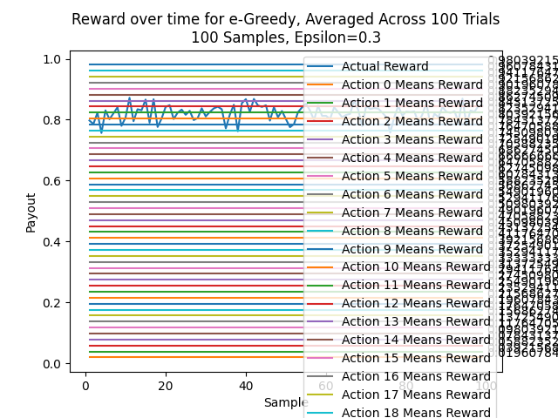

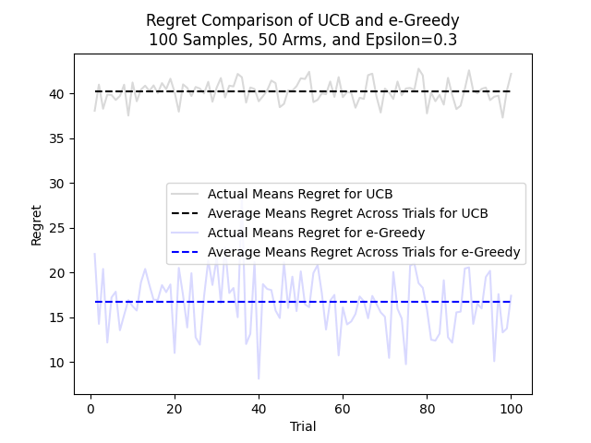

### 100 Samples, 100 Trials, 99 Arms, Std Dev=0.1

#### 100 Samples, 100 Trials, 99 Arms, Epsilon=0.1 Std Dev=0.1

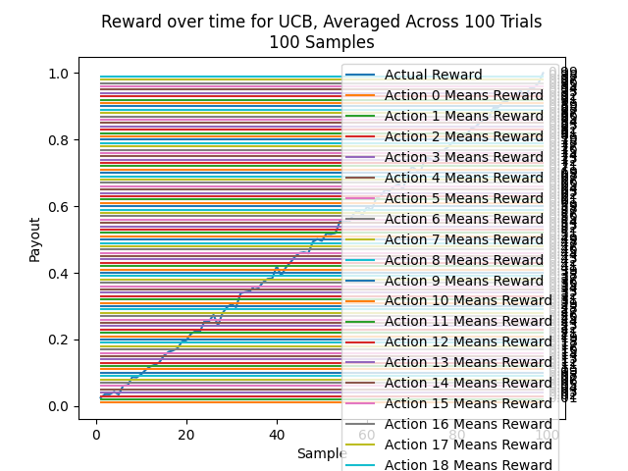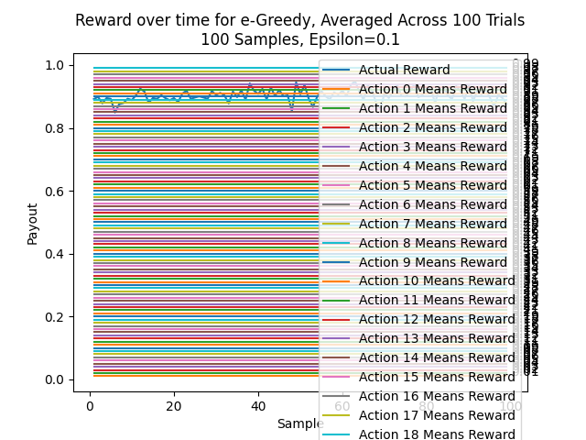

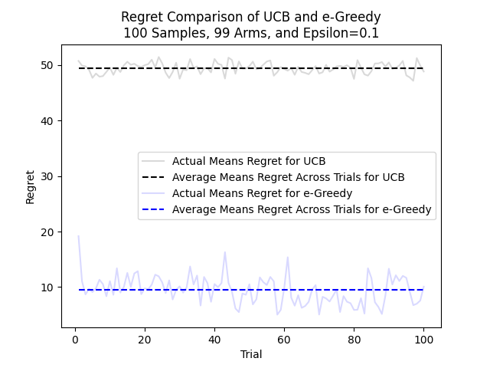

#### 100 Samples, 100 Trials, 99 Arms, Epsilon=0.2 Std Dev=0.1

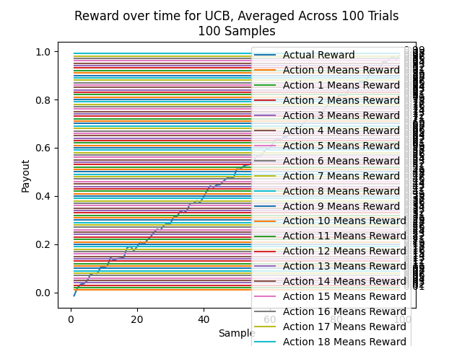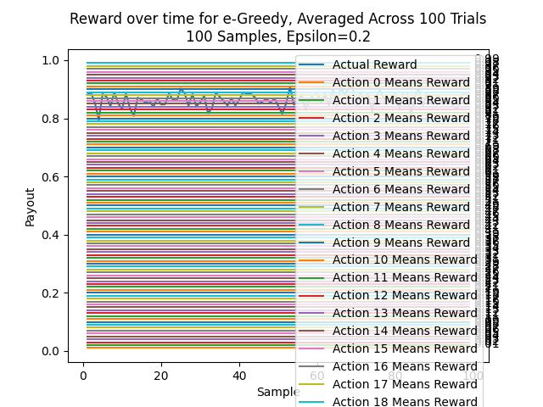

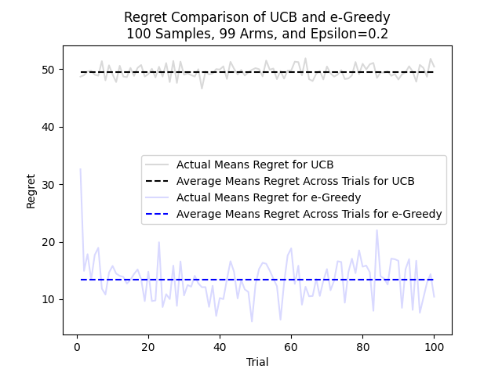

#### 100 Samples, 100 Trials, 99 Arms, Epsilon=0.3 Std Dev=0.1

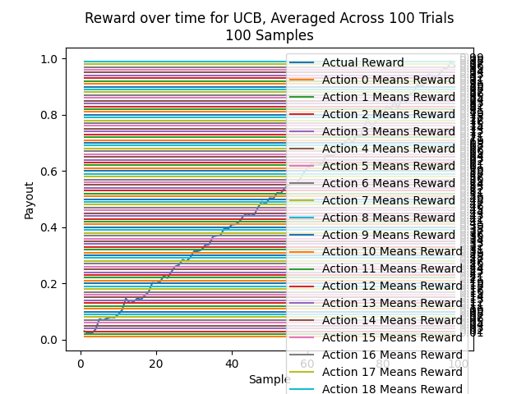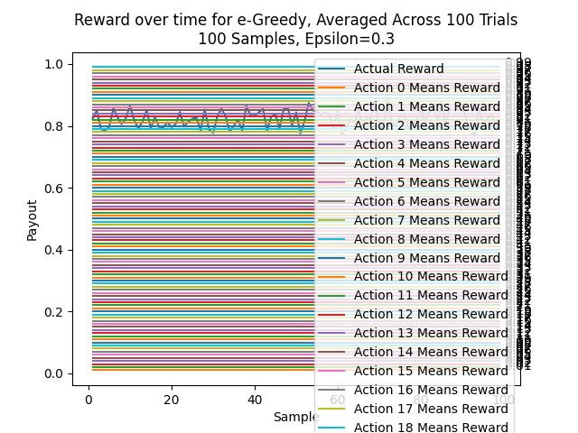

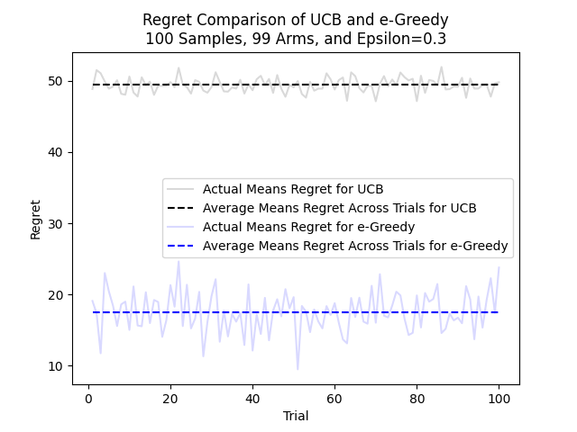

### 1000 Samples, 100 Trials, 3 Arms, Std Dev=0.1

#### 1000 Samples, 100 Trials, 3 Arms, Epsilon=0.1 Std Dev=0.1

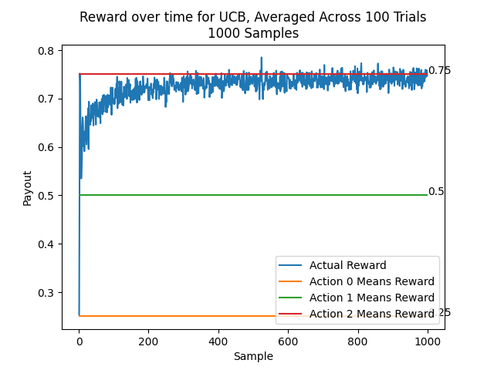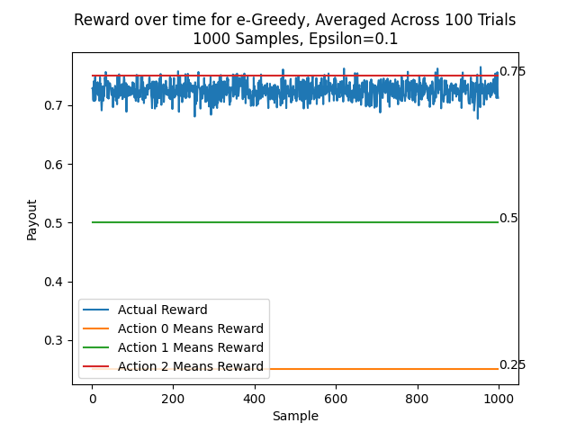

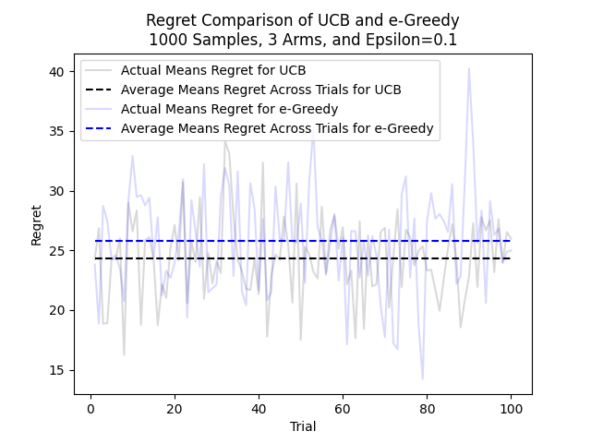

#### 1000 Samples, 100 Trials, 3 Arms, Epsilon=0.2 Std Dev=0.1

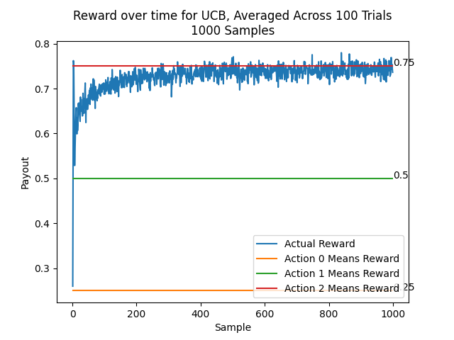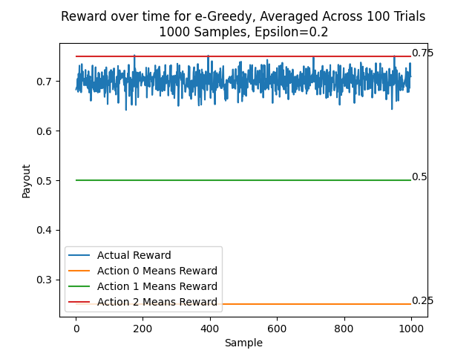

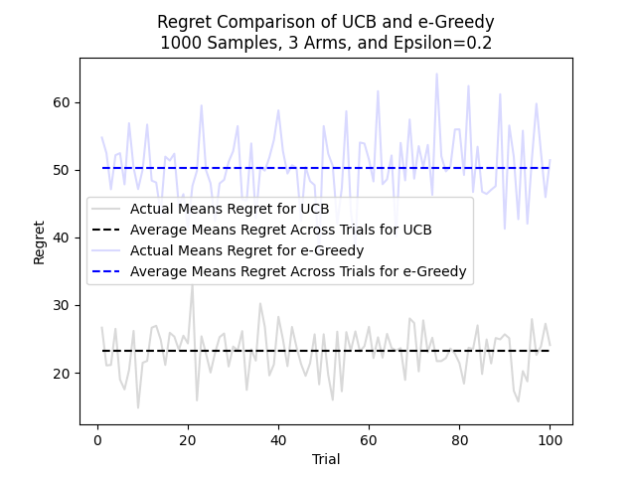

#### 1000 Samples, 100 Trials, 3 Arms, Epsilon=0.3 Std Dev=0.1

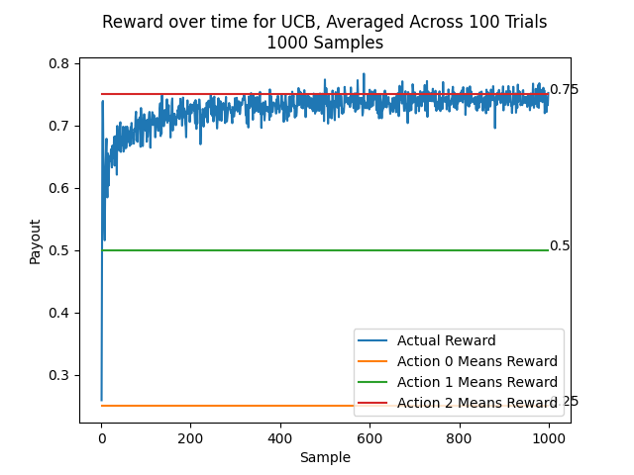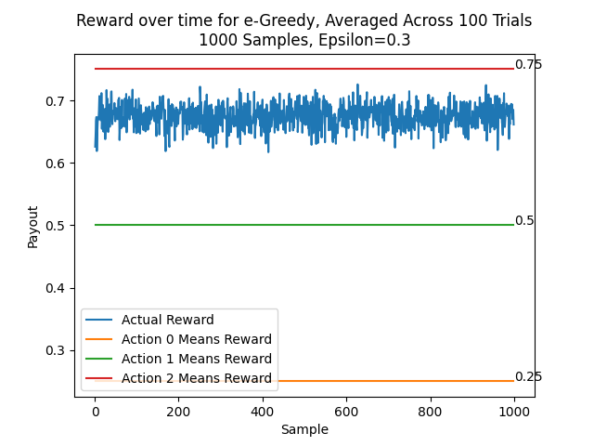

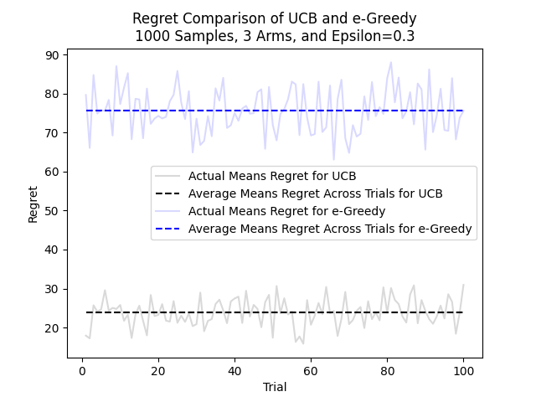

### 1000 Samples, 100 Trials, 10 Arms, Std Dev=0.1

#### 1000 Samples, 100 Trials, 10 Arms, Epsilon=0.1 Std Dev=0.1

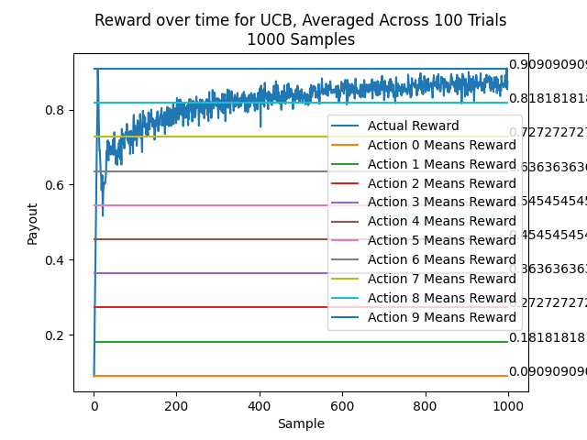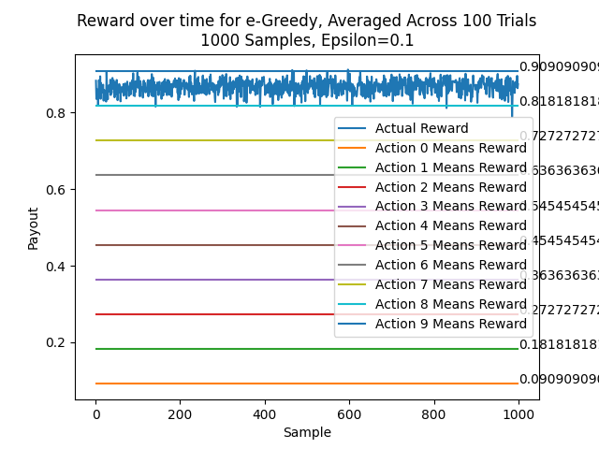

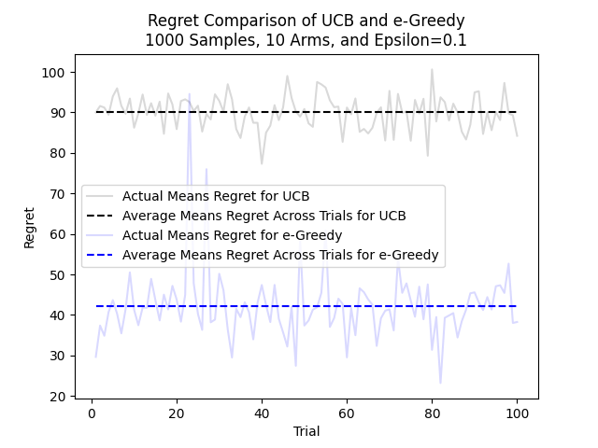

#### 1000 Samples, 100 Trials, 10 Arms, Epsilon=0.2 Std Dev=0.1

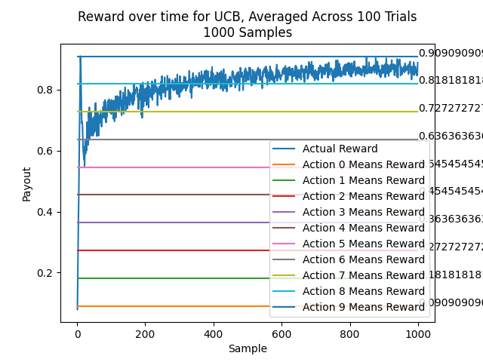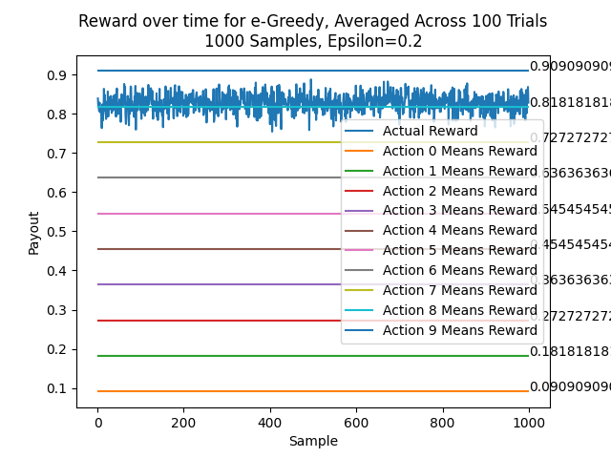

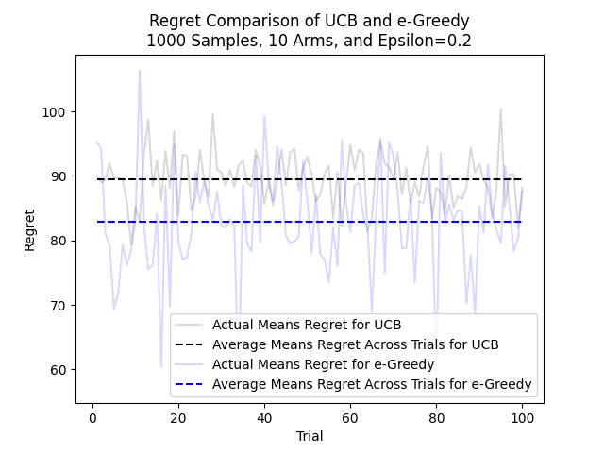

#### 1000 Samples, 100 Trials, 10 Arms, Epsilon=0.3 Std Dev=0.1

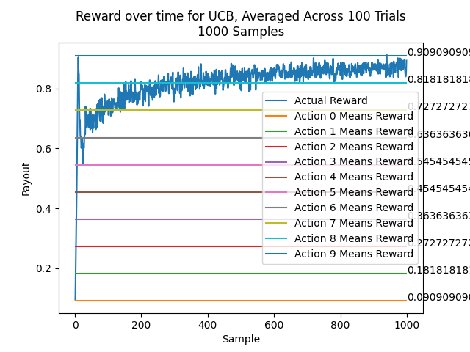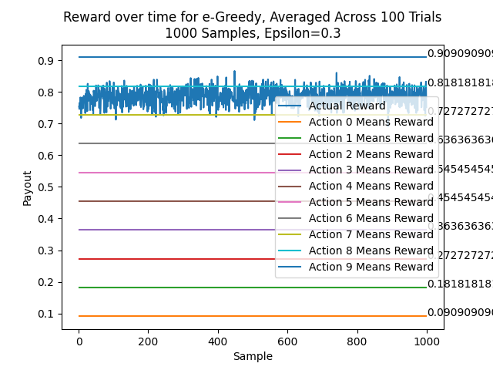

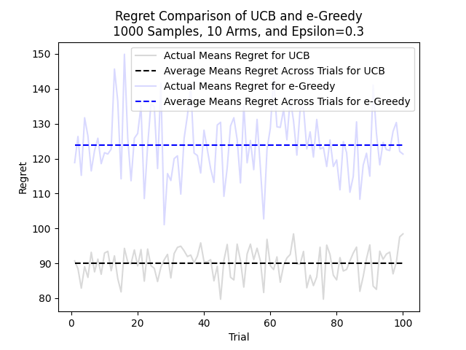

### 1000 Samples, 100 Trials, 50 Arms, Std Dev=0.1

#### 1000 Samples, 100 Trials, 50 Arms, Epsilon=0.1 Std Dev=0.1

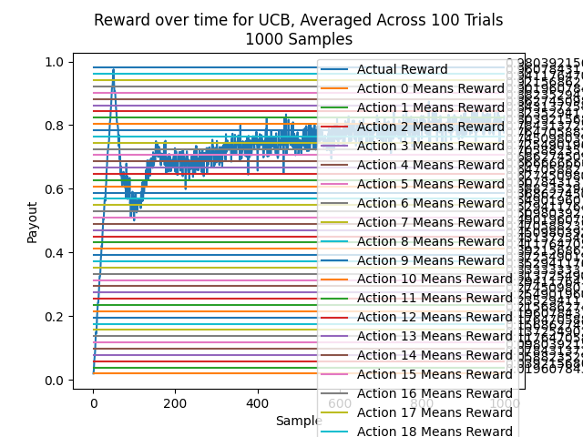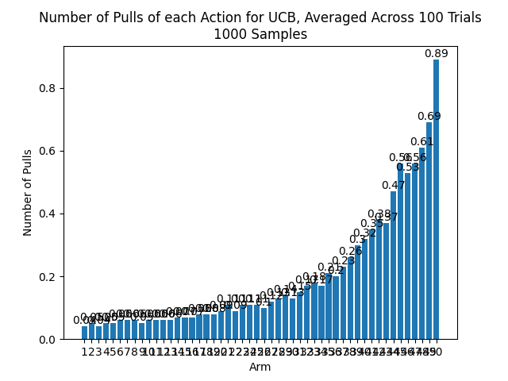

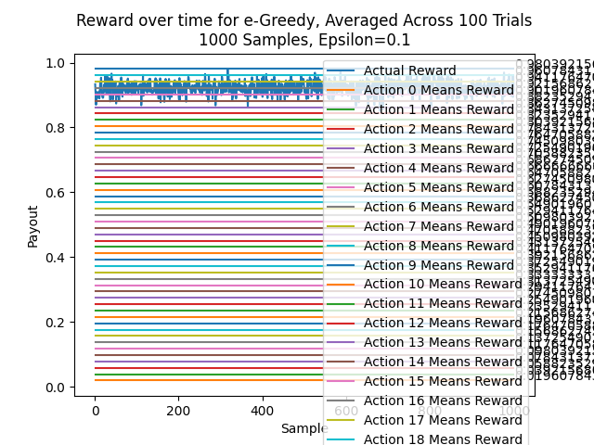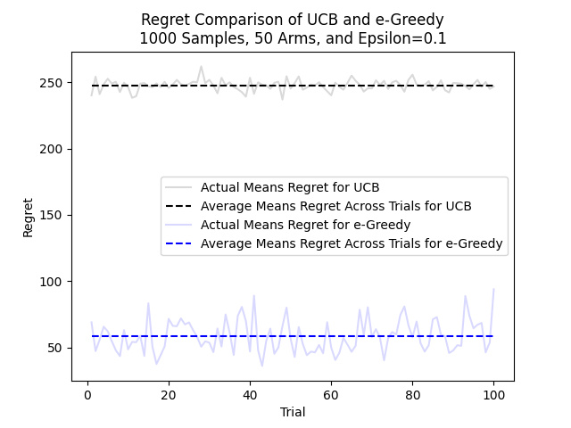

#### 1000 Samples, 100 Trials, 50 Arms, Epsilon=0.2 Std Dev=0.1

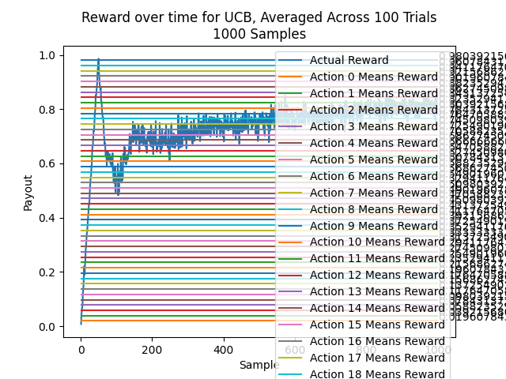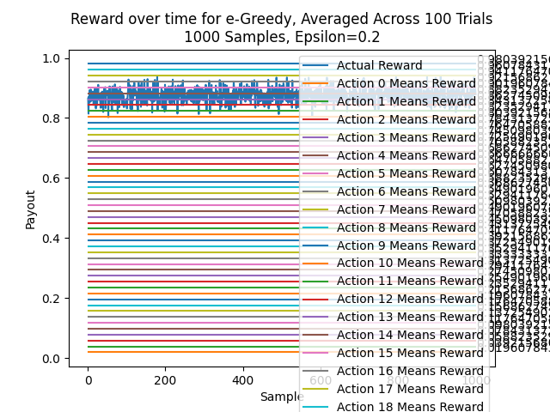

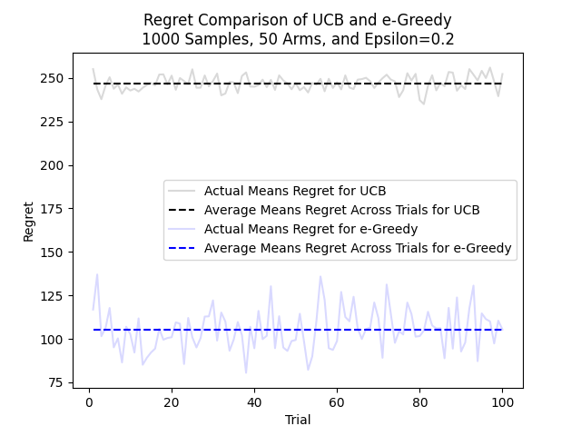

#### 1000 Samples, 100 Trials, 50 Arms, Epsilon=0.3 Std Dev=0.1

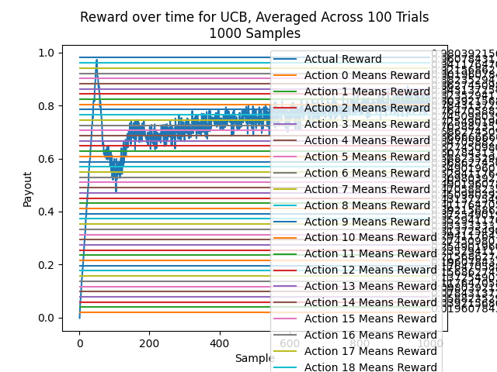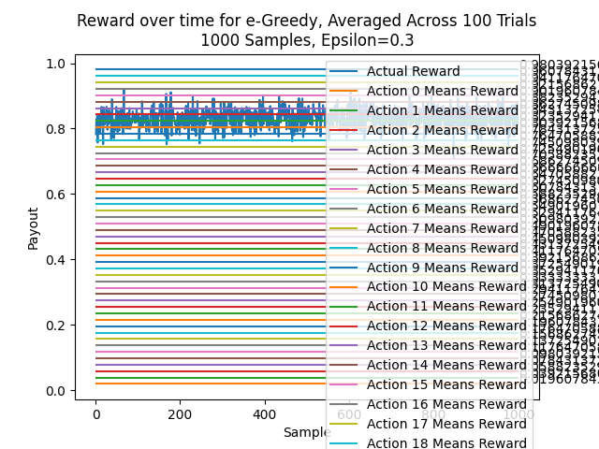

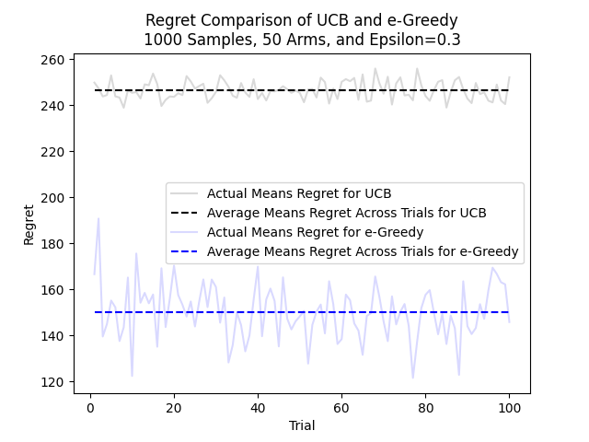

### 1000 Samples, 100 Trials, 99 Arms, Std Dev=0.1

#### 1000 Samples, 100 Trials, 99 Arms, Epsilon=0.1 Std Dev=0.1

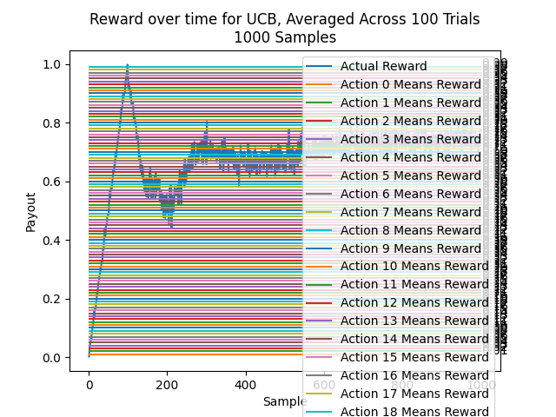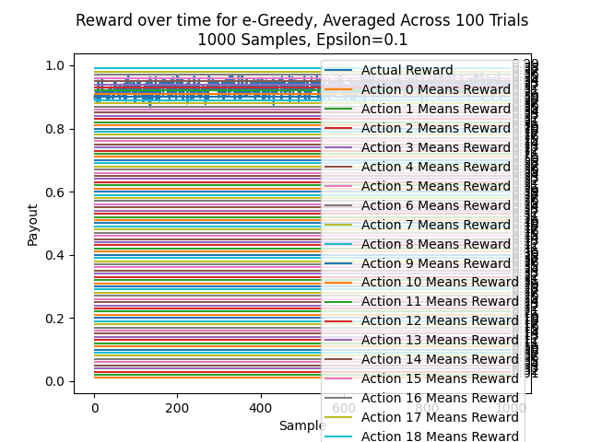

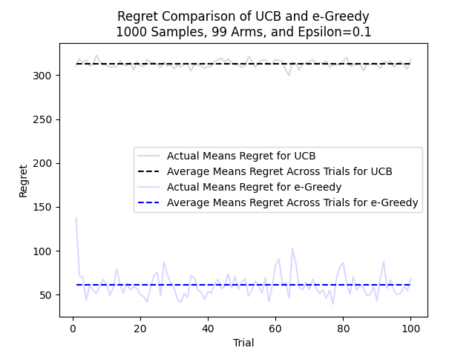

#### 1000 Samples, 100 Trials, 99 Arms, Epsilon=0.2 Std Dev=0.1

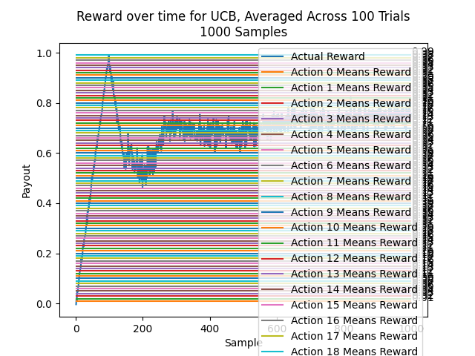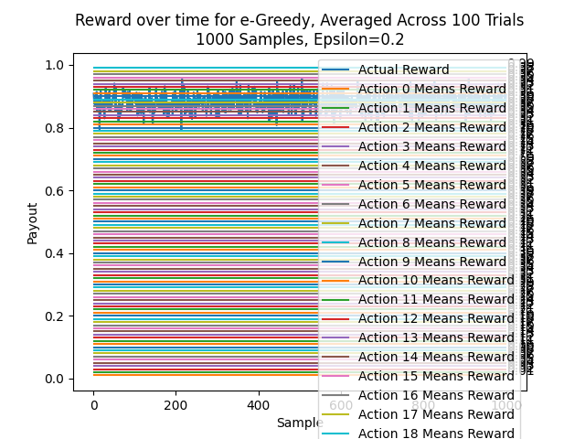

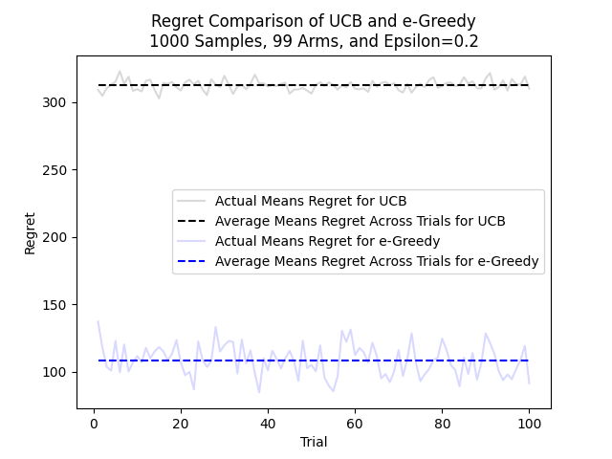

#### 1000 Samples, 100 Trials, 99 Arms, Epsilon=0.3 Std Dev=0.1

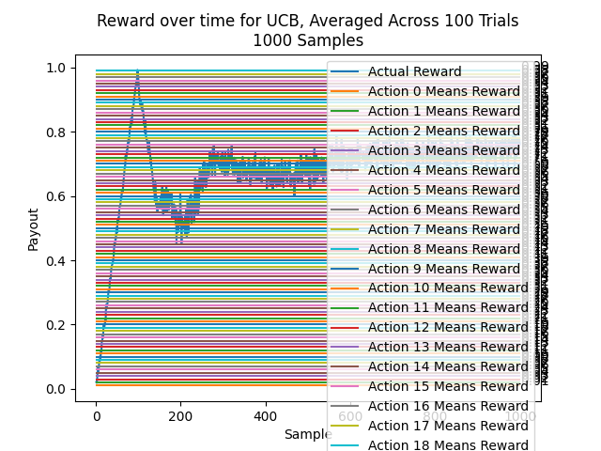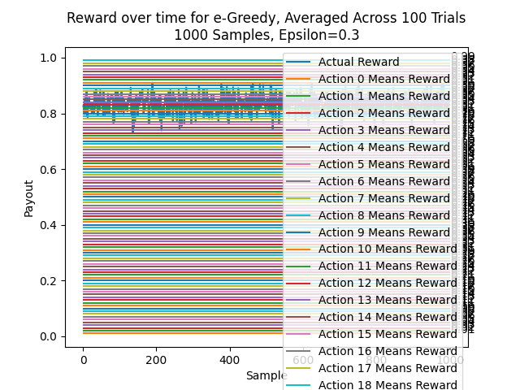

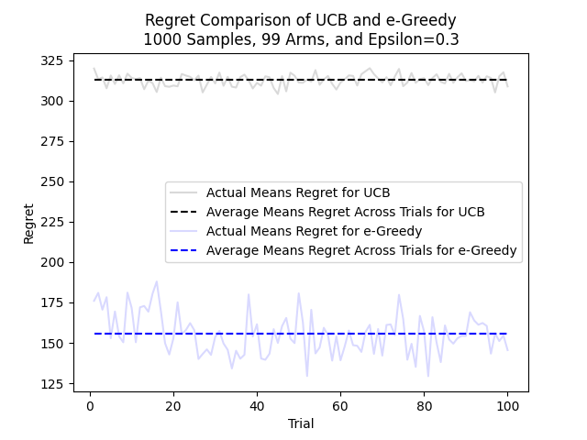

## Additional Domain: Standard Deviation = 0.05

### 1000 Samples, 100 Trials, 3 Arms, Std Dev=0.05

#### 1000 Samples, 100 Trials, 3 Arms, Epsilon=0.1 Std Dev=0.05

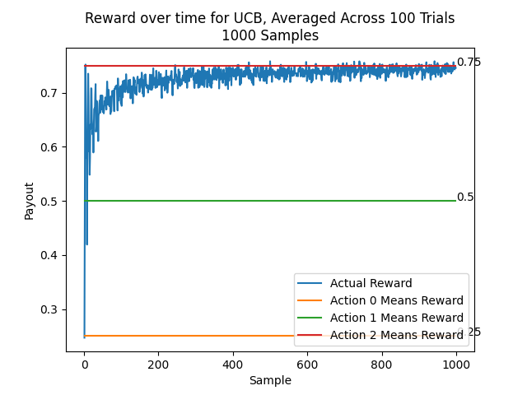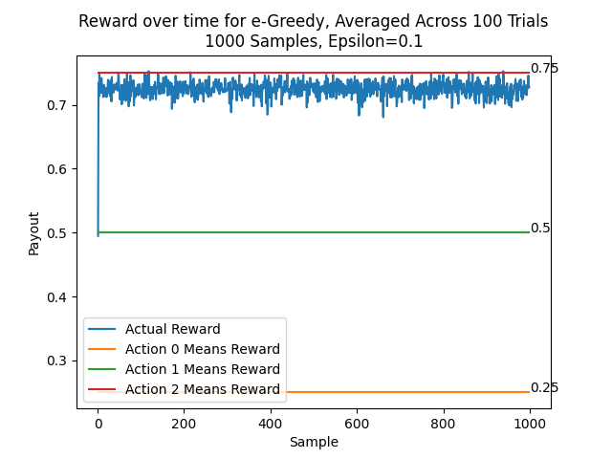

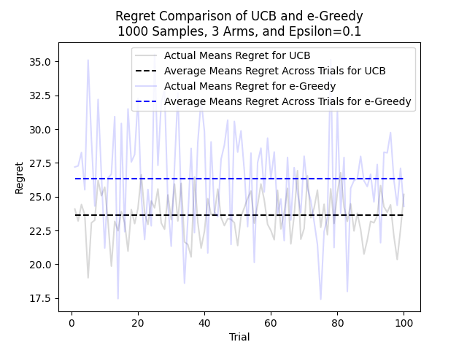

#### 1000 Samples, 100 Trials, 3 Arms, Epsilon=0.2 Std Dev=0.05

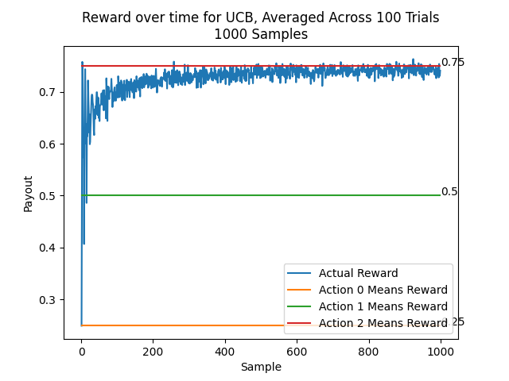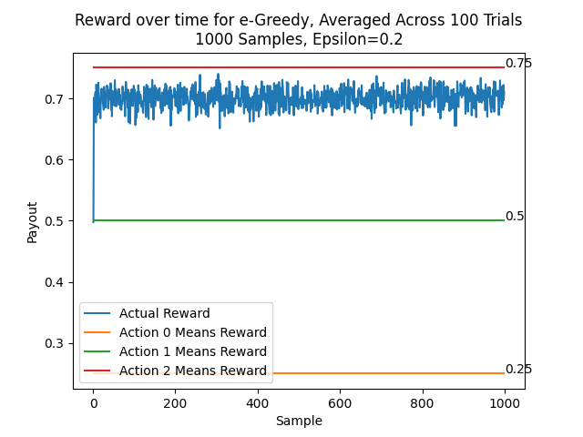

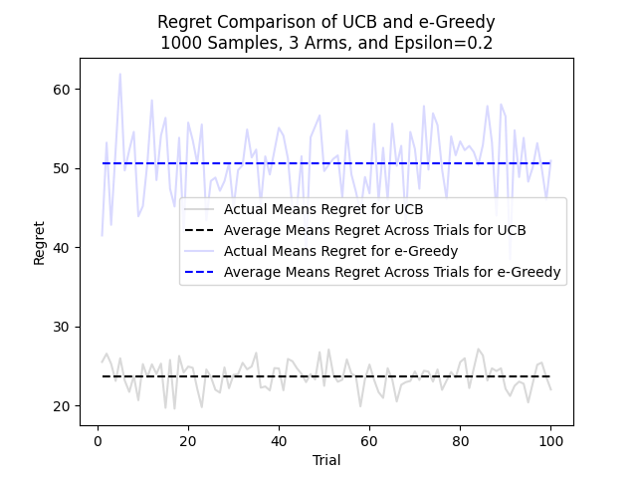

#### 1000 Samples, 100 Trials, 3 Arms, Epsilon=0.3 Std Dev=0.05

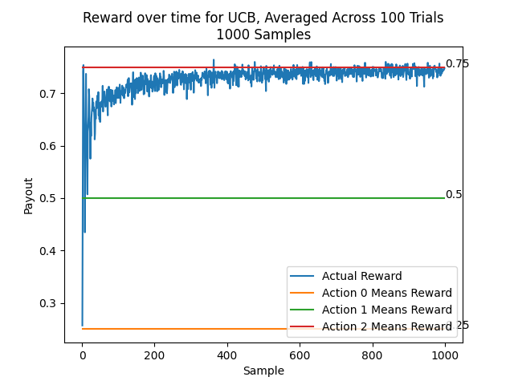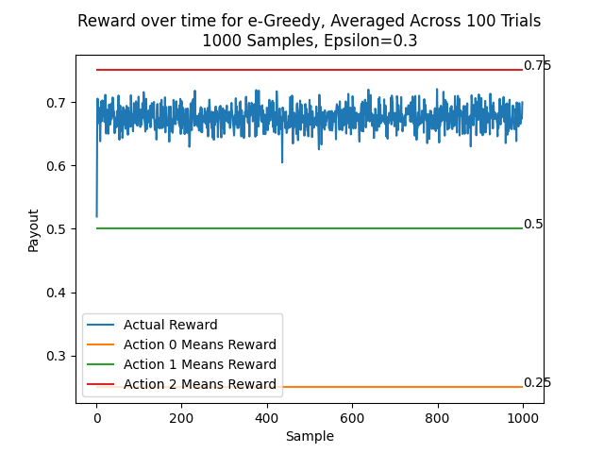

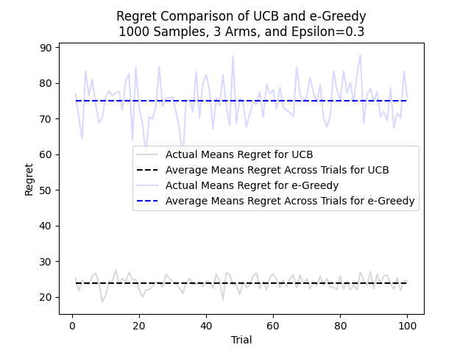

### 1000 Samples, 100 Trials, 50 Arms, Std Dev=0.05

#### 1000 Samples, 100 Trials, 50 Arms, Epsilon=0.1 Std Dev=0.05

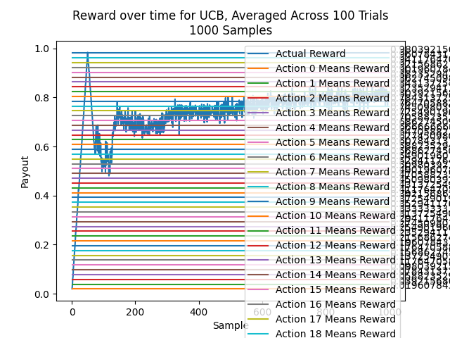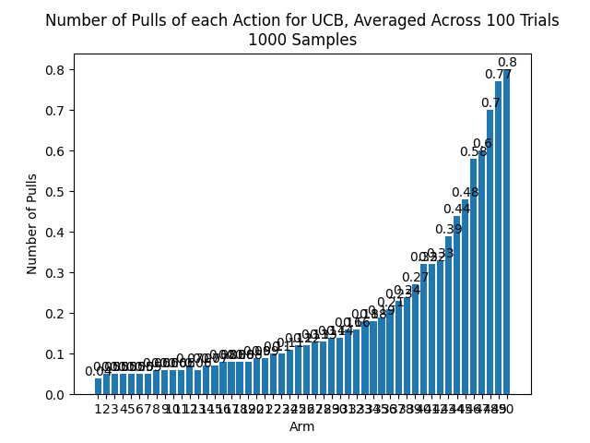

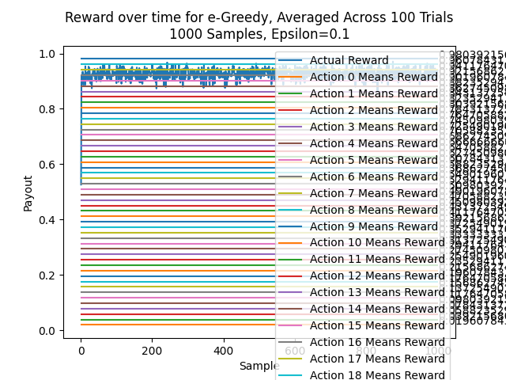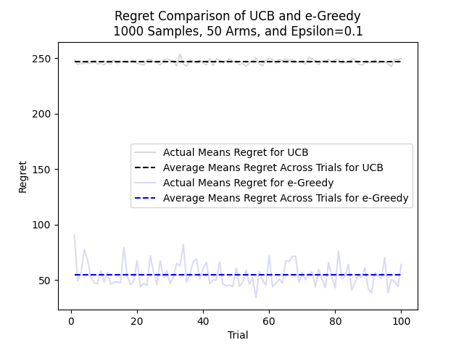

#### 1000 Samples, 100 Trials, 50 Arms, Epsilon=0.2 Std Dev=0.05

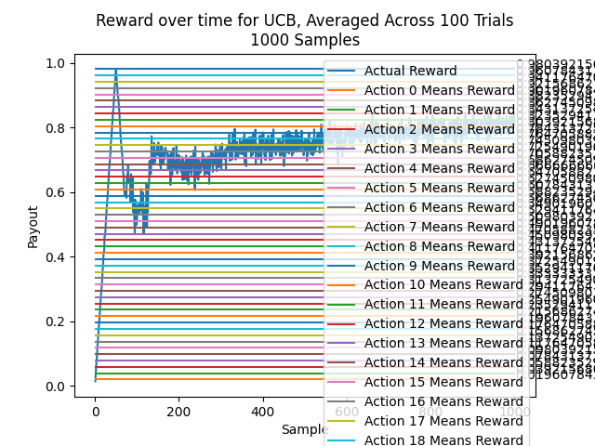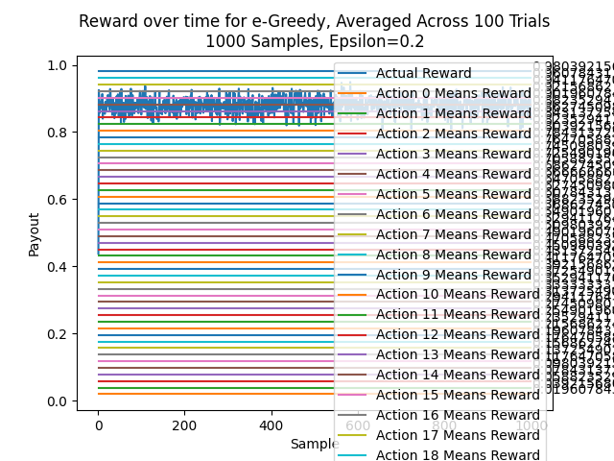

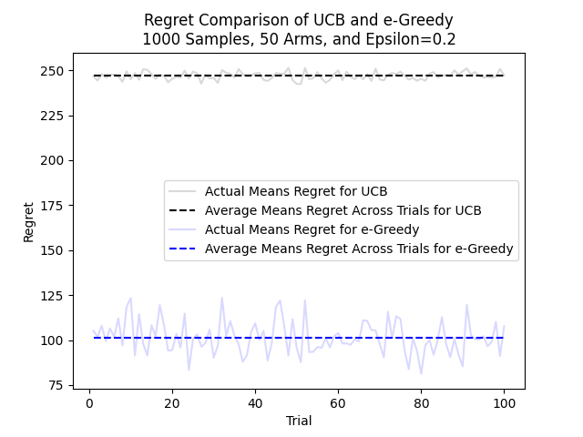

#### 1000 Samples, 100 Trials, 50 Arms, Epsilon=0.3 Std Dev=0.05

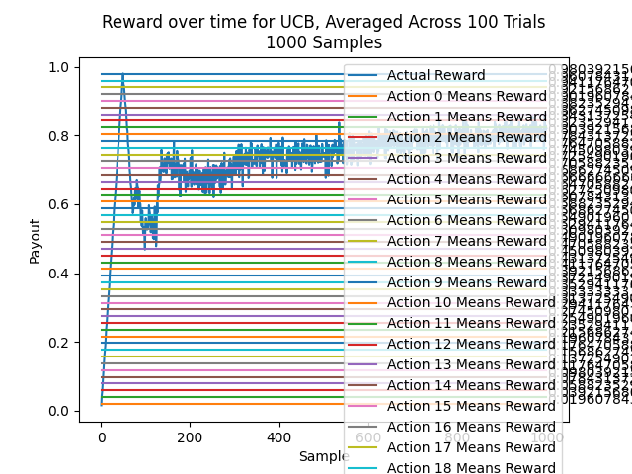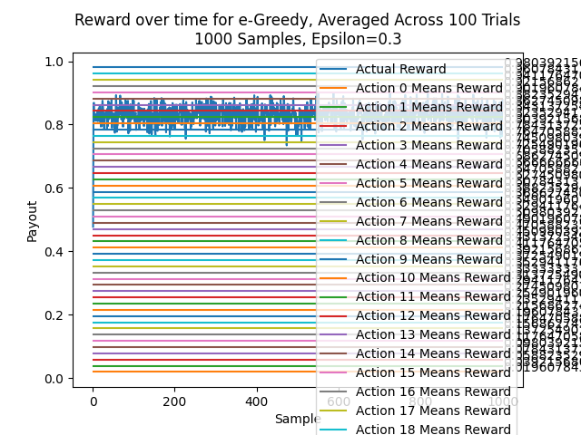

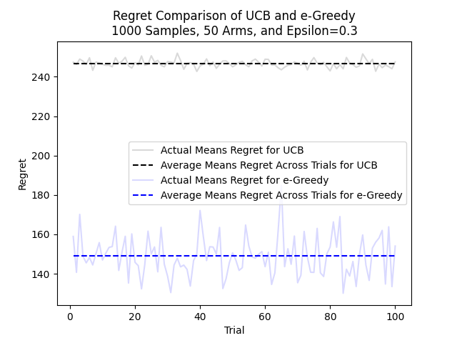

### 1000 Samples, 100 Trials, 99 Arms, Std Dev=0.05

#### 1000 Samples, 100 Trials, 99 Arms, Epsilon=0.1 Std Dev=0.05

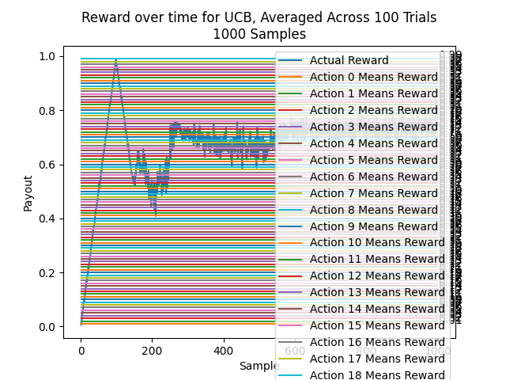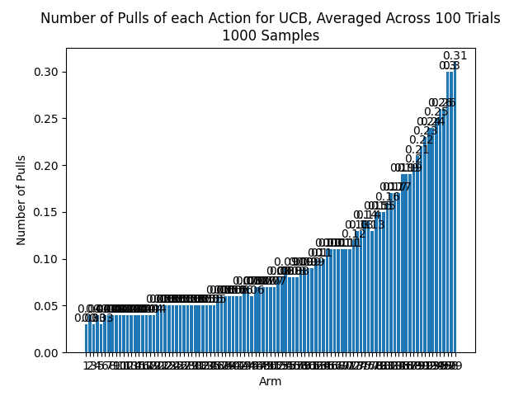

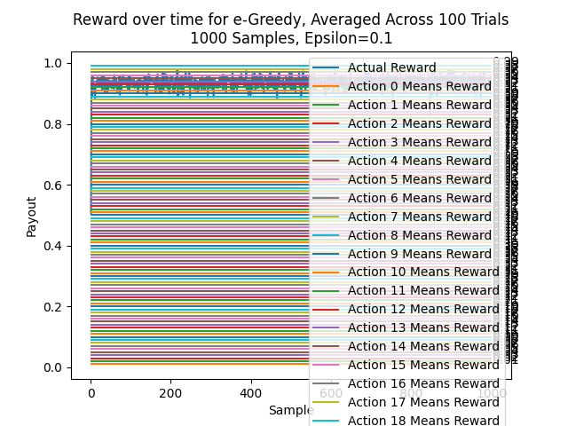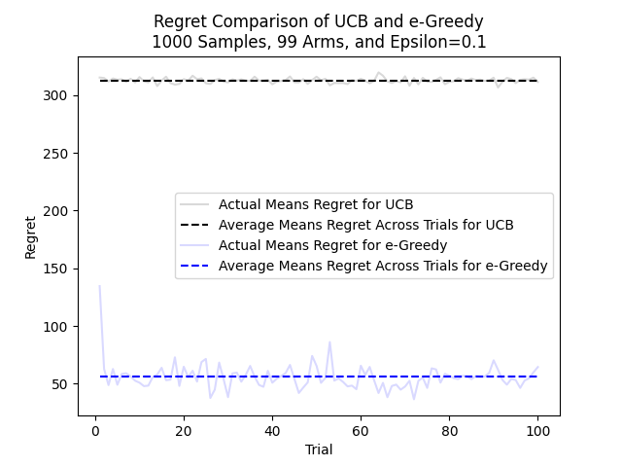

#### 1000 Samples, 100 Trials, 99 Arms, Epsilon=0.2 Std Dev=0.05

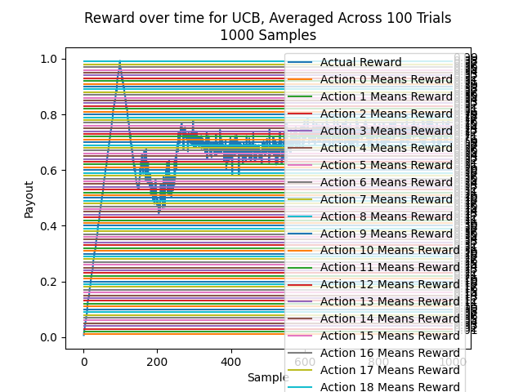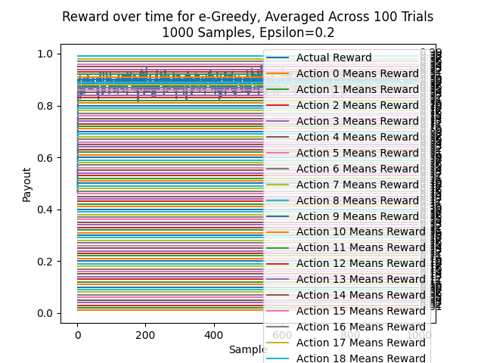

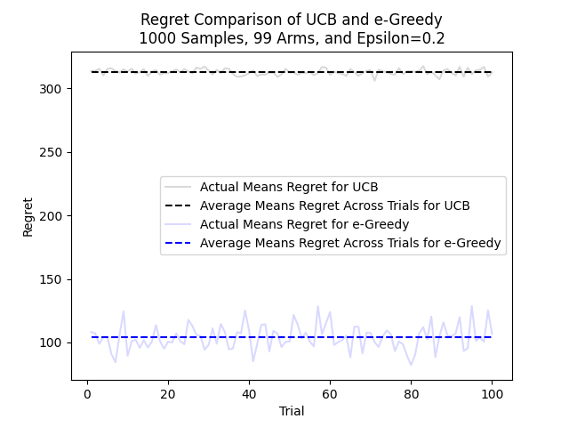

#### 1000 Samples, 100 Trials, 99 Arms, Epsilon=0.3 Std Dev=0.05

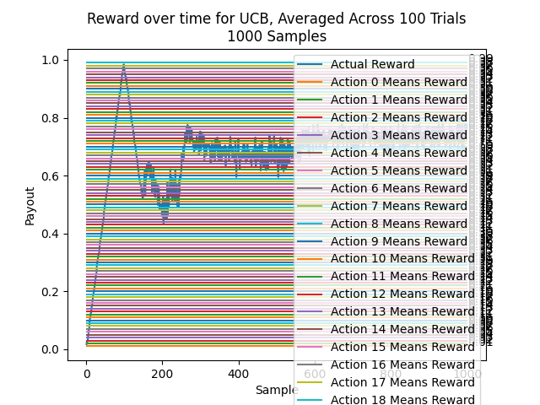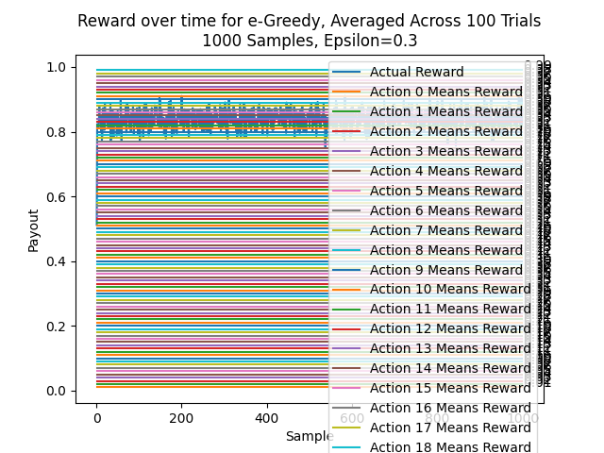

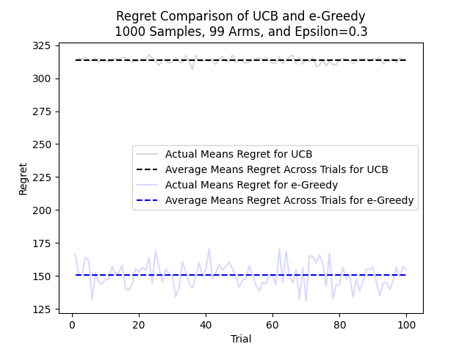

## Additional Domain: Standard Deviation = 0.2

### 1000 Samples, 100 Trials, 3 Arms, Std Dev=0.2

#### 1000 Samples, 100 Trials, 3 Arms, Epsilon=0.1 Std Dev=0.2

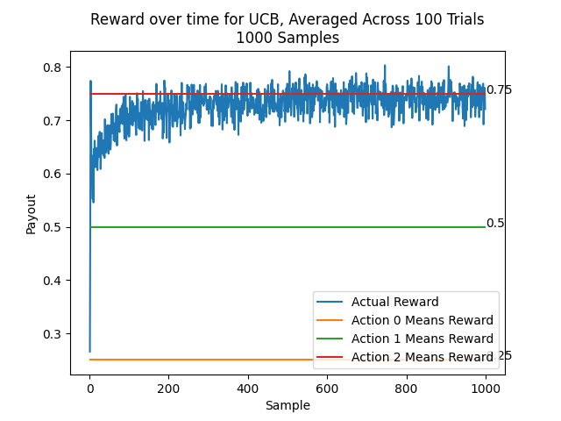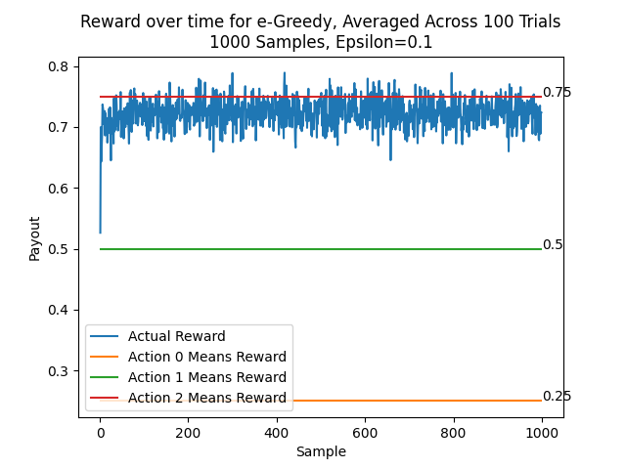

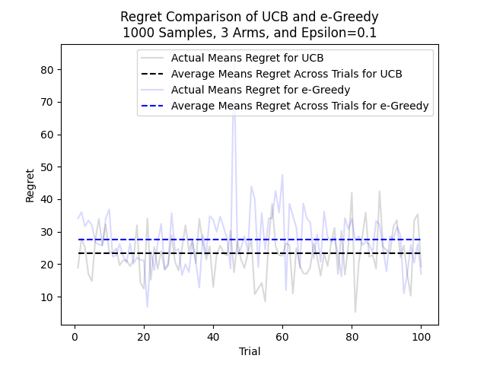

#### 1000 Samples, 100 Trials, 3 Arms, Epsilon=0.2 Std Dev=0.2

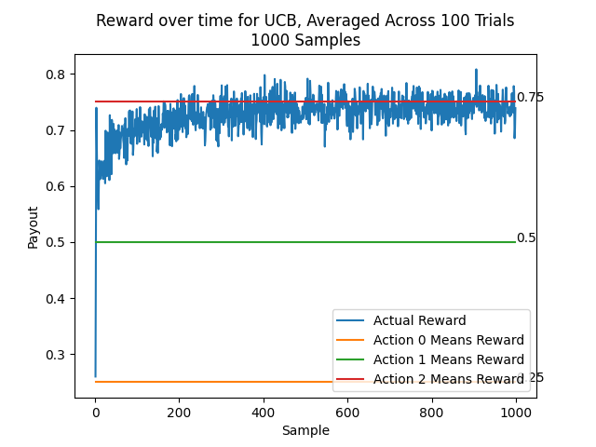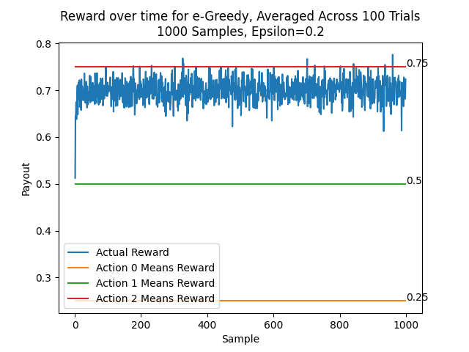

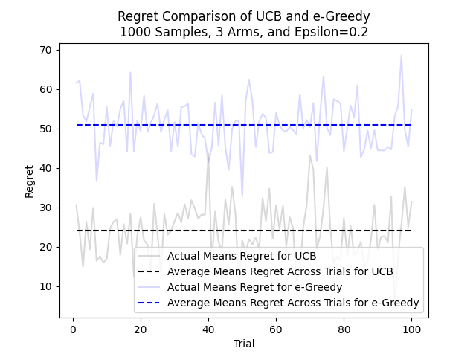

#### 1000 Samples, 100 Trials, 3 Arms, Epsilon=0.3 Std Dev=0.2

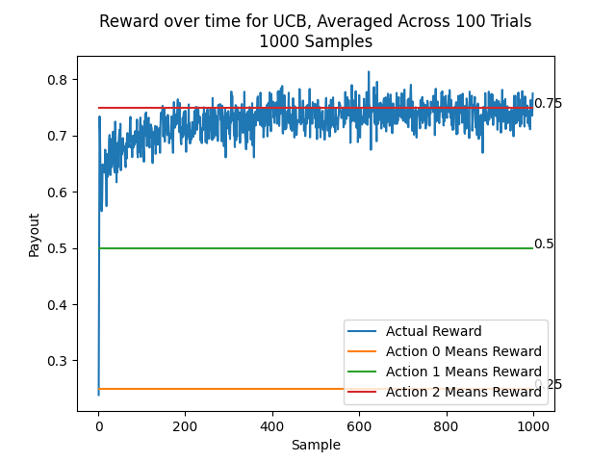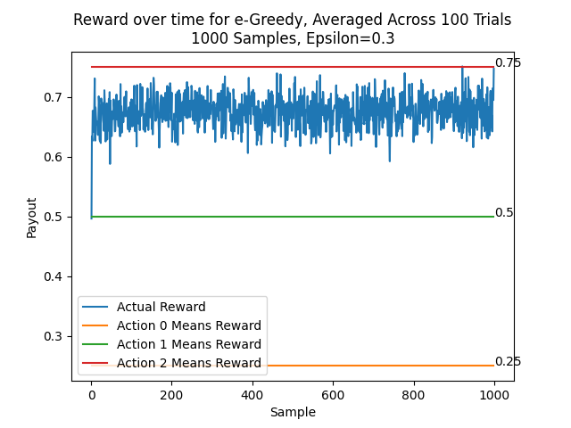

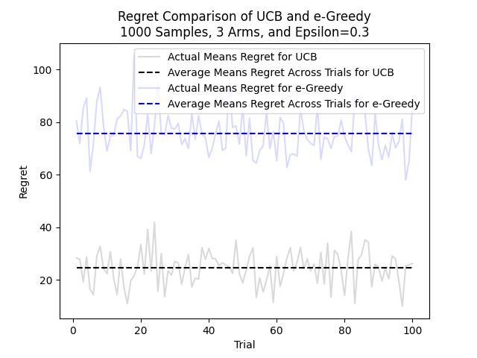

### 1000 Samples, 100 Trials, 50 Arms, Std Dev=0.2

#### 1000 Samples, 100 Trials, 50 Arms, Epsilon=0.1 Std Dev=0.2

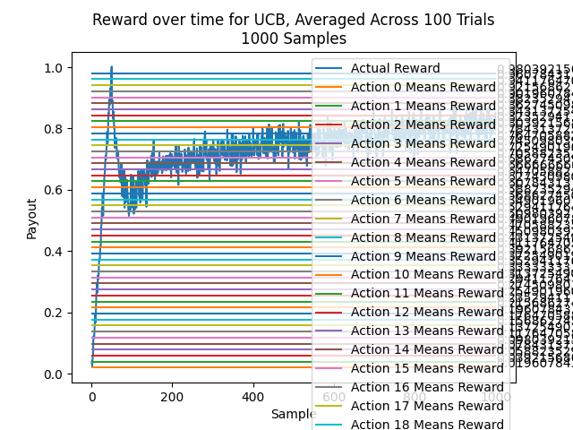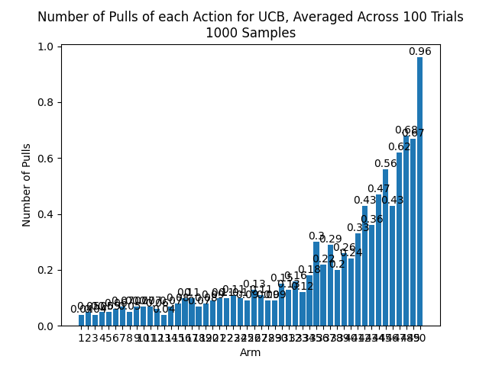

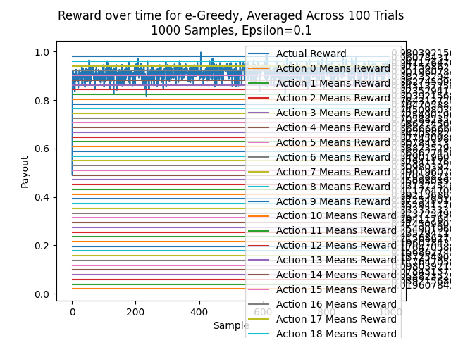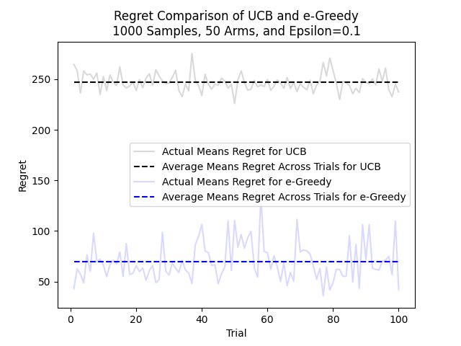

#### 1000 Samples, 100 Trials, 50 Arms, Epsilon=0.2 Std Dev=0.2

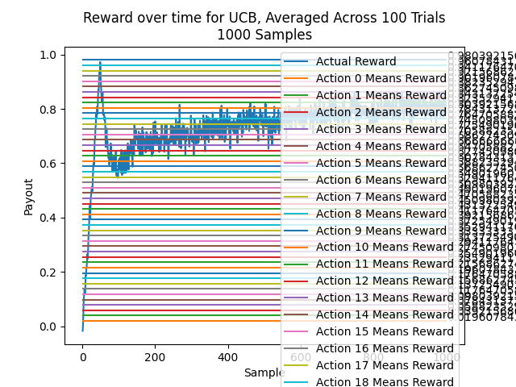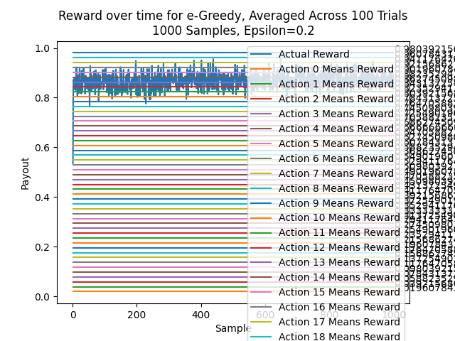

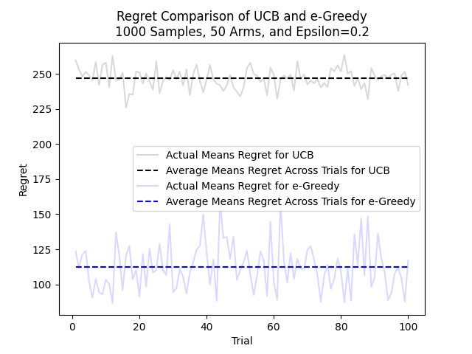

#### 1000 Samples, 100 Trials, 50 Arms, Epsilon=0.3 Std Dev=0.2

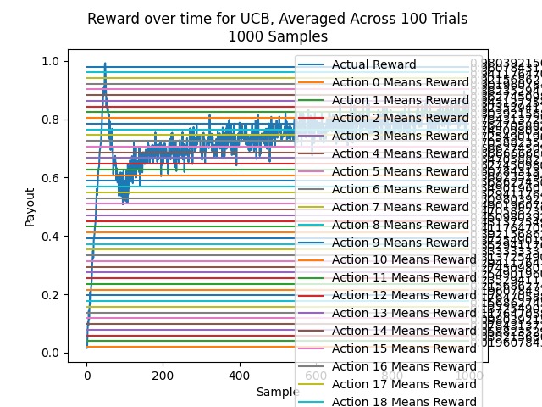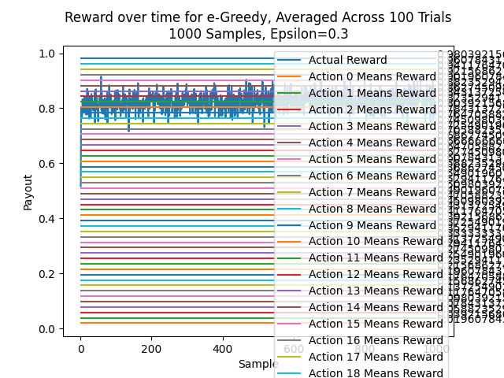

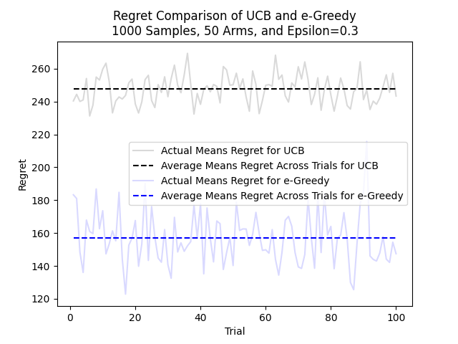

### 1000 Samples, 100 Trials, 99 Arms, Std Dev=0.2

#### 1000 Samples, 100 Trials, 99 Arms, Epsilon=0.1 Std Dev=0.2

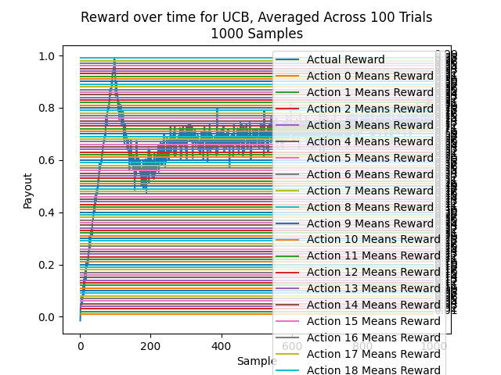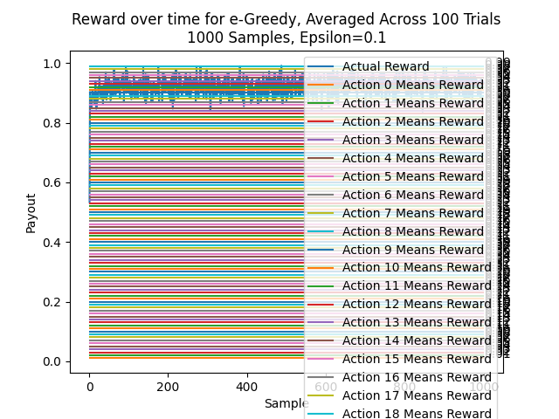

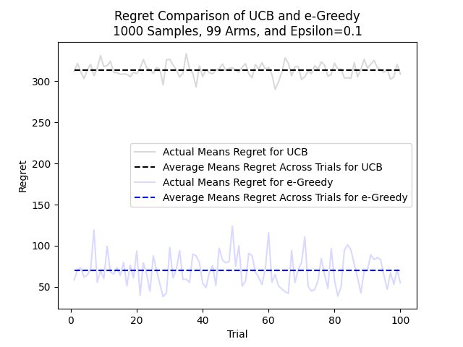

#### 1000 Samples, 100 Trials, 99 Arms, Epsilon=0.2 Std Dev=0.2

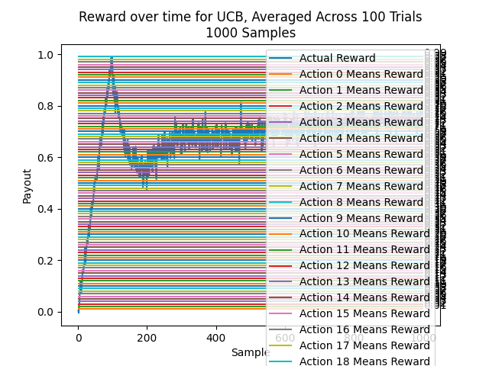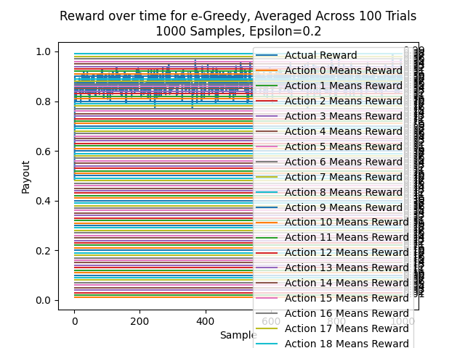

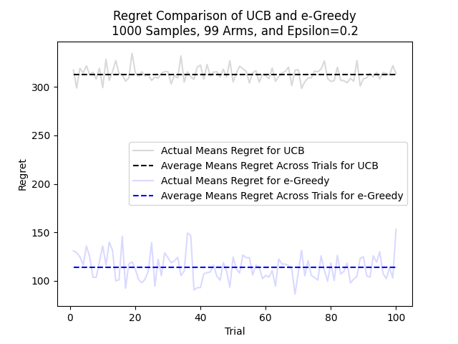

#### 1000 Samples, 100 Trials, 99 Arms, Epsilon=0.3 Std Dev=0.2

